Judaism Concepts and Key Questions covered
Key Stage 1 | Mitzvot/ tzedakah  Why is learning to do good deeds so important to Jewish people? | Tefillah/ blessings  Why do Jewish families say so many prayers and blessings? | Teshuvah / G-D  Why do Jewish families talk about repentance at New Year?
Torah / rabbi  Why is the Torah such a joy for the Jewish community? | Key Stage 2 | 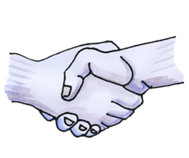What symbols and stories help Jewish people remember their covenant with God? | 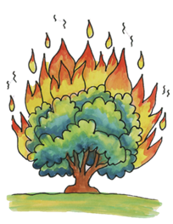What is holiness for Jewish people: a place, a time, an object or something else?

End of phase Judaism Core knowledge : What do we want pupils to know?
By the end of KS1, pupils learn about the importance of the Torah for Jewish people. They encounter some of the stories such as creation, Jonah or Ruth and discuss possible meanings. Importantly they learn Jewish people follow the teachings of the Torah as a rule book for life and learn about how the Torah is remembered and respected. They learn about the importance of Shabbat and the role of other Jewish festivals.

By the end of KS2, pupils learn about some of the Torah stories in more detail, especially the Exodus story and the importance of covenant with God for Jewish people. They extend their learning into philosophical and theological conversation about holiness and describe and compare different Jewish celebrations.
Please note: the above will depend on if both Judaism units are taught in your KS2 scheme of work.

