Multi Cultural Day 29.11.18
The children from both schools came together in the Village Hall to explore 6 different faiths and what it means to belong to them. We had speakers from Buddhism, Sikhism, Islam, Humanists, Judaism and Hinduism who bought artefacts to show then children and activities for them to participate in.
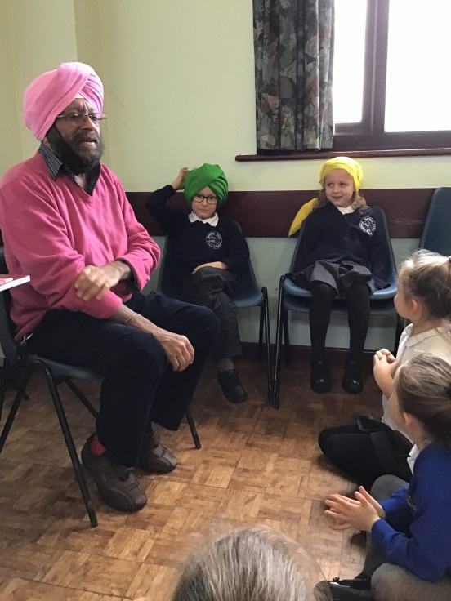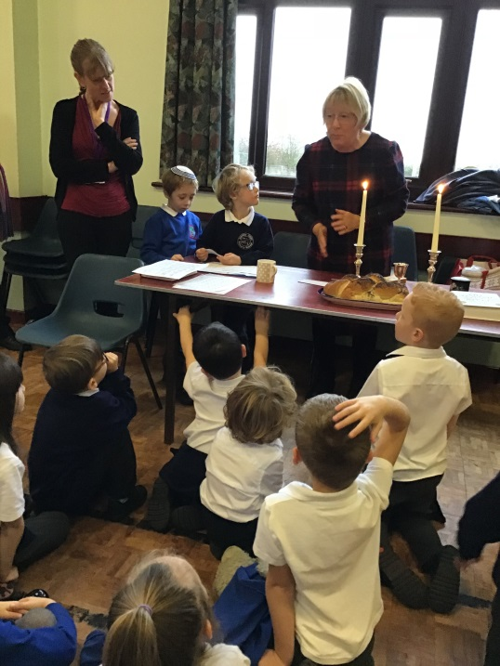
Sikhism Judaism
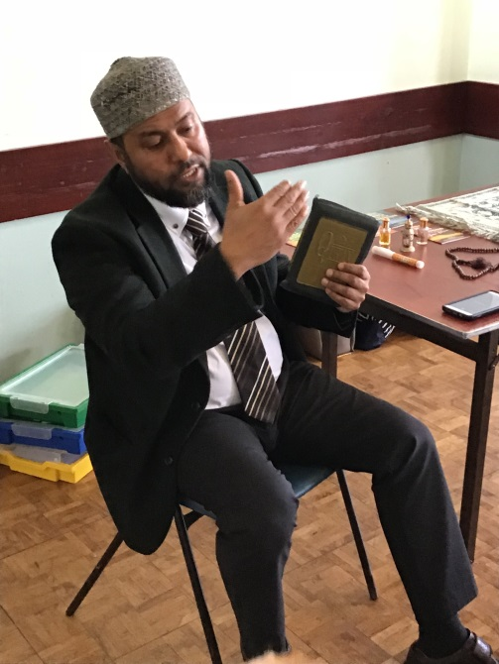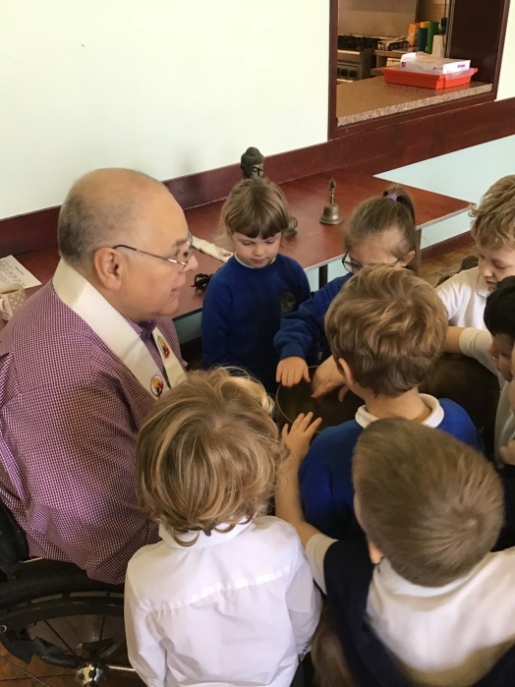
Islam Buddhism
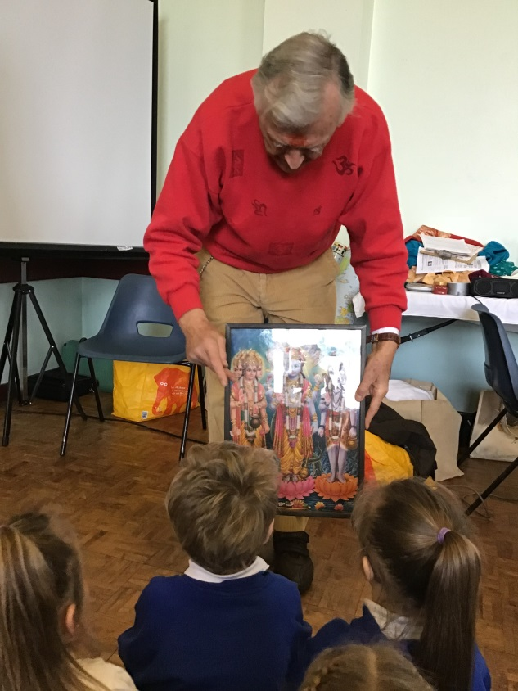
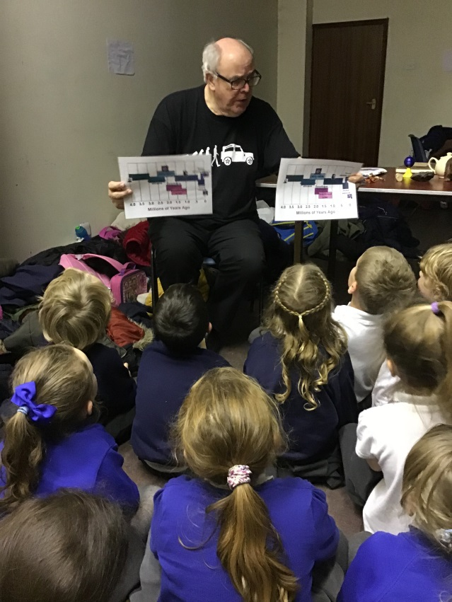
Humanism Hinduism

