Easter bonnet parade
On Wednesday 28th March, worship group led the Easter church service with the help of some actors from Adders Class who retold the Easter story as time travellers.
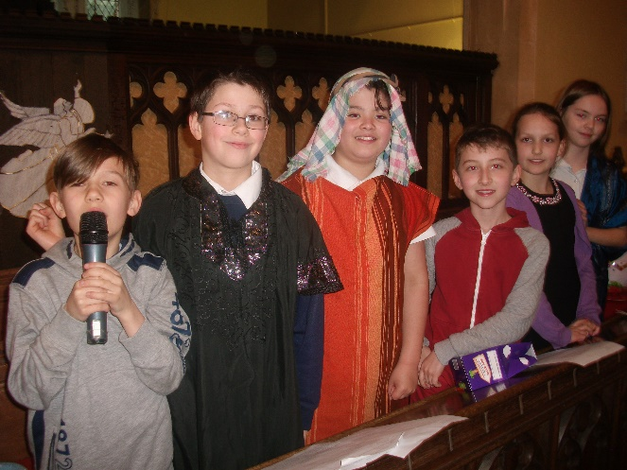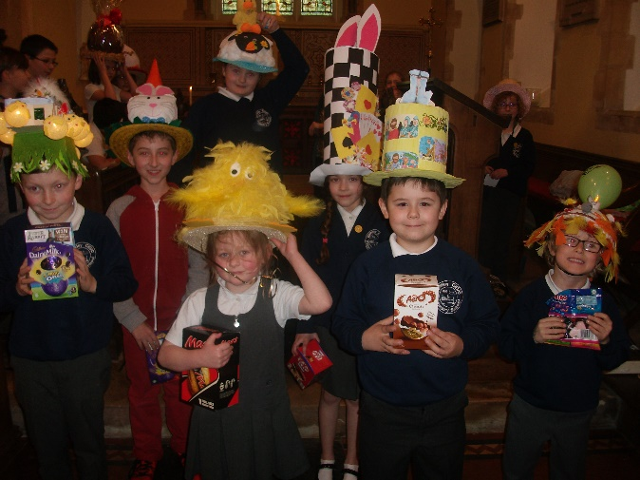
And the winners of the Easter bonnets were Noah, Natalia, Harry, Nicholas, Isla, Charlie and Yasmine.

