Dressing children for a Tudor event

This is a quick guide to anyone who has never made costume before.
There are many places to find suitable material in the back of a cupboard, in the attic or charity shops.
Old curtains are the best to ‘mine’ for cloth (use the lining as well). It is not always necessary to buy material. Wash material that is second hand or been stored for a while as I managed to import bugs once.
The charity shop is also a good place to find suitable extras like baskets, toys or suitable drinking vessels.
The most important thing is to have fun making them.
My grand children

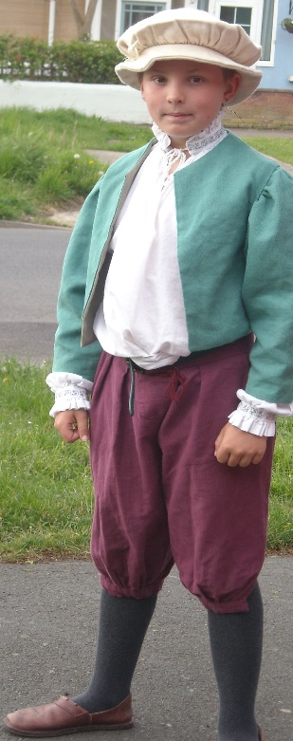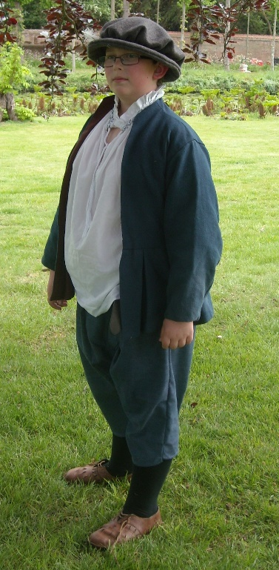
.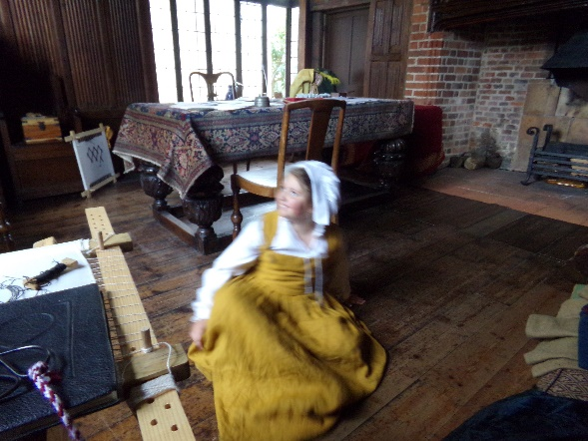
Dressing Children for Tudor Event

For a quick costume for children the easiest by far is the simplest.

For Girls.
A white blouse or white school shirt.
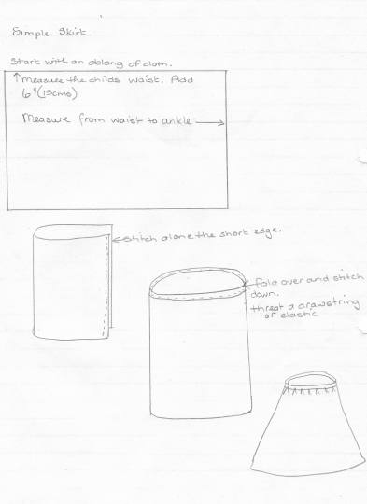
A skirt, a long skirt made like a tube with a draw string or elastic at the waist. Do not make these over long as long skirts, for people who are not used to wearing one, can be a trip hazard. Just above the ankle.

A waistcoat top with a cord in the front to make it look for Tudor.
An apron, these can be made with waist ties or can be tucked into the top of the skirt.
A small basket can be added also as they are very useful for pennies, sweets, and other useful items.
The coif, the little white hat, can be made from a strip of white material wrapped around the head. From experience these do not stay on for long if tied too tightly. It is best to experiment, a head band may help to keep them in place.

For boys.
A white school shirt.
A waistcoat again with a cord in the front to make it look more Tudor.
A pair of trousers they can be tucked into the tops of long socks. If shorts or if trousers are cut short a boy can just wear them and a pair of shoes. There is no need in this case for him to wear socks if not wanted.
Boys and men also wore a coif. For boys they can get away with not wearing one. If you wish to make one the directions are further on. They are not hard to sew.

In both cases a pair of flat shoes are the best for the right look,

Depending on what you wish to achieve you can also add a cloak, a drinking vessel (a cup) or a toy. Any small item a child may need. Not any electronic items though.

The above is the easiest and most cost effective way to create the ‘look’.

For those who wish to be more adventurous with a needle.

Boys Breeches.
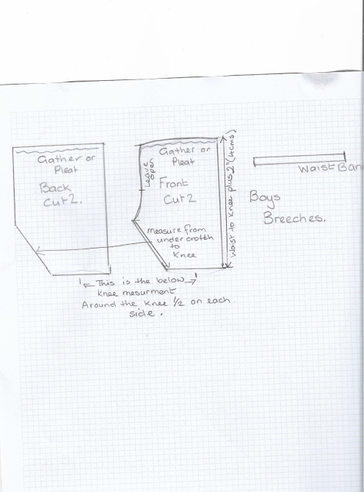
- Measure the boys waist.

- Measure from the waist to just below the knee. (when drawing out the pattern add 2inches(5cms) to the side seams front and back to allow for movement.

- Cut a strip of cloth the size of the waist plus 2inches (5cms)
- Cut out the Breeches with a seam allowance of ½ inch
(1cms.)

- Pin the front leg pieces to the back and stitch down the long seam.

- Pin and stitch the under crotch seam this should give you a basic garment. 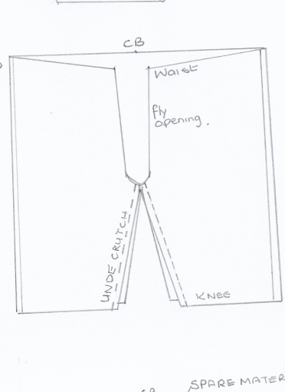
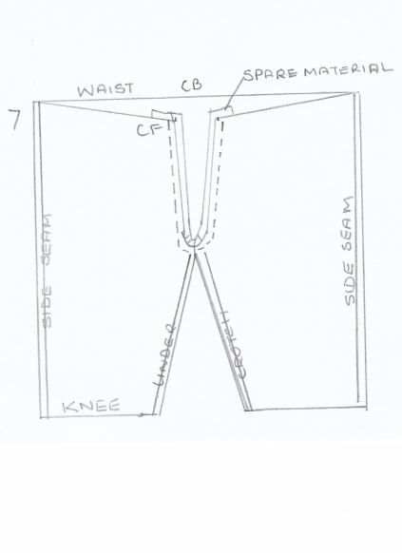

- Pin a spare piece of material along the opening of the fly. You can use this to add buttons, hooks, Velcro to close the opening.

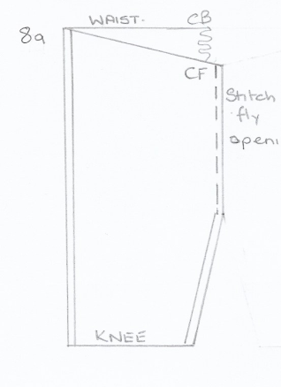
- SHORT METHOD If you do not wish to do this you can either make a waist band or turn the top edge of the beeches over to make a pocket and add elastic or a drawstring instead. N.B Make sure the child can get the breeches on. If you wish to have a waist band follow next steps.

Stitch up the front fly

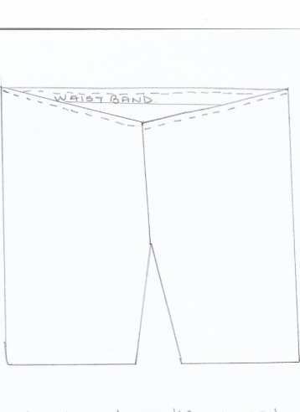
the waist band in place

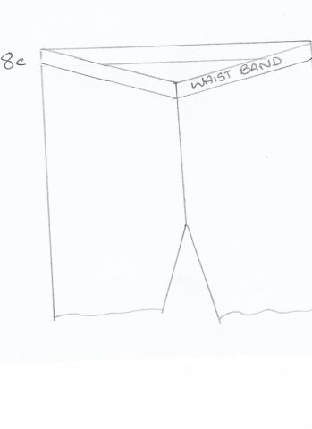

turnover and stitch down forming a pocket then add elastic or a drawstring.

- If you are not using the ‘short method’ follow next steps. Setting the gathers or pleats in place to the size of the child’s waist. Add the waist band if you have not already done so. Using the same instructions, (but not of course adding the elastic) as laid out above.
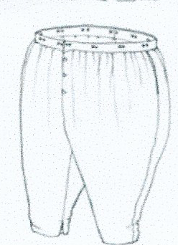
- Add hooks, buttons or Velcro to front fly and hem around the bottom, if required.

These are the finished Breeches

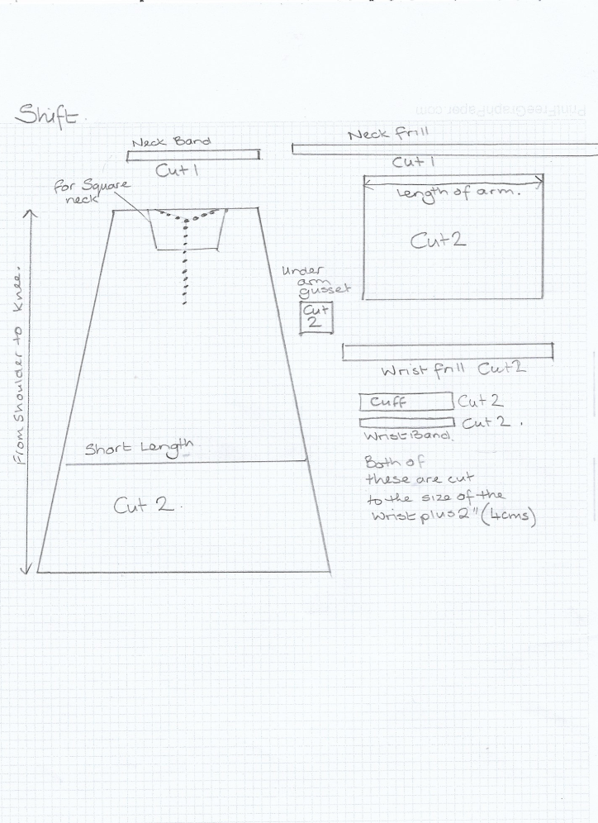

Shift and shirt

This is simpler than it looks. It is based on rectangles and squares. The body has two rectangles. The sleeves are also rectangles. There is a little square that fits under the arm to give more room. (I would suggest if this is only going to be worn once to leave it out.)

The pattern I have drawn up is for 4 types of garment. A long and short shift and a long and short shirt. The patterns for both are the same. It is only the length that is the difference. I have made the pattern larger at the bottom but for most children a straight rectangle is all that they need.
Generally the slit opening is for a boy and the square neck is for a girl. Although a girl can wear the slit opening a boy does not wear the square neck.

For the shirt. (boy)
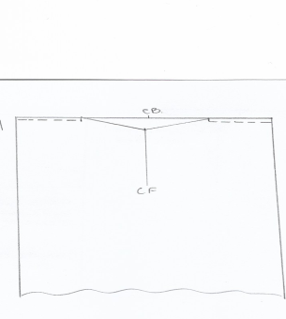
This is the pattern with the dotted line at the neck. I would make the boys shirt to the knees. It is not so bulky to tuck into the breeches. The neck line can just be left plain or a frill can be added. For ease leave it plain.
- Stitch the shoulder seam.

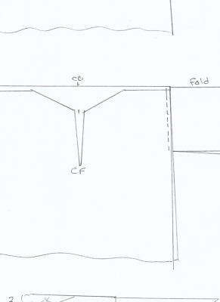
- Add the sleeves.

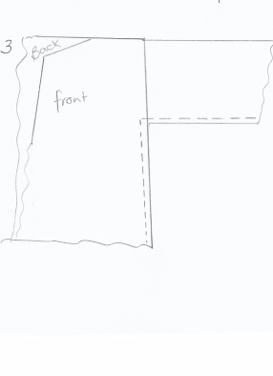
- Stitch the under arm from the base of the sleeve to the bottom of the garment.
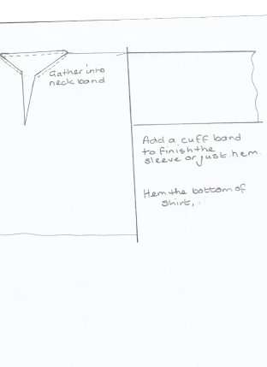

- Add the frill if using.

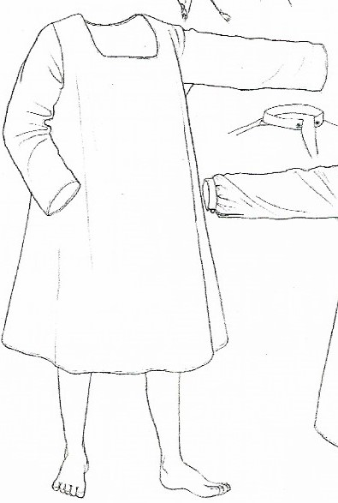
For the girls shift.

Follow the same directions as for the boys shirt but the girls garment is usually longer.

If you wish to have a square neck it should be bound or the raw edge stitched under.

The picture shows the girls shift. The sleeves have no cuff and the neck line is simply rolled under and stitched.
You can see how to finish the neck line and cuffs of the boys shirt.
Girls and boys waist coat.

I have given a basic pattern for both boys and girls. This is fairly easy to construct.
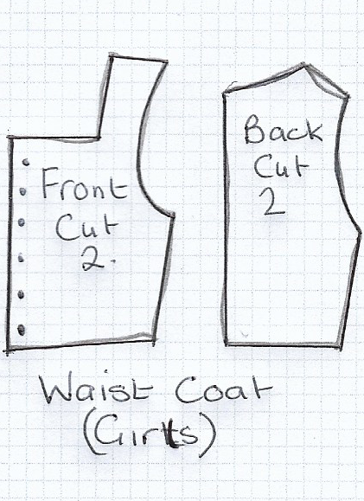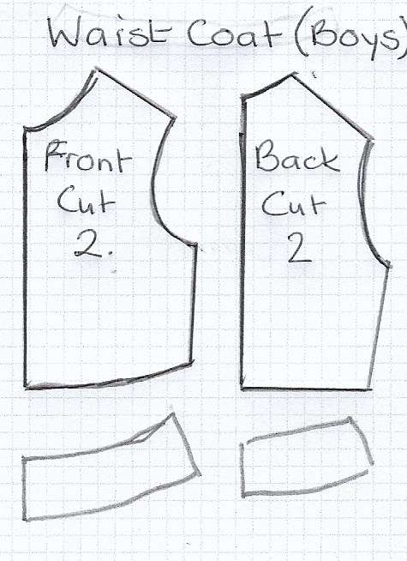

This pattern has the small ‘skirt’ I would not use it.
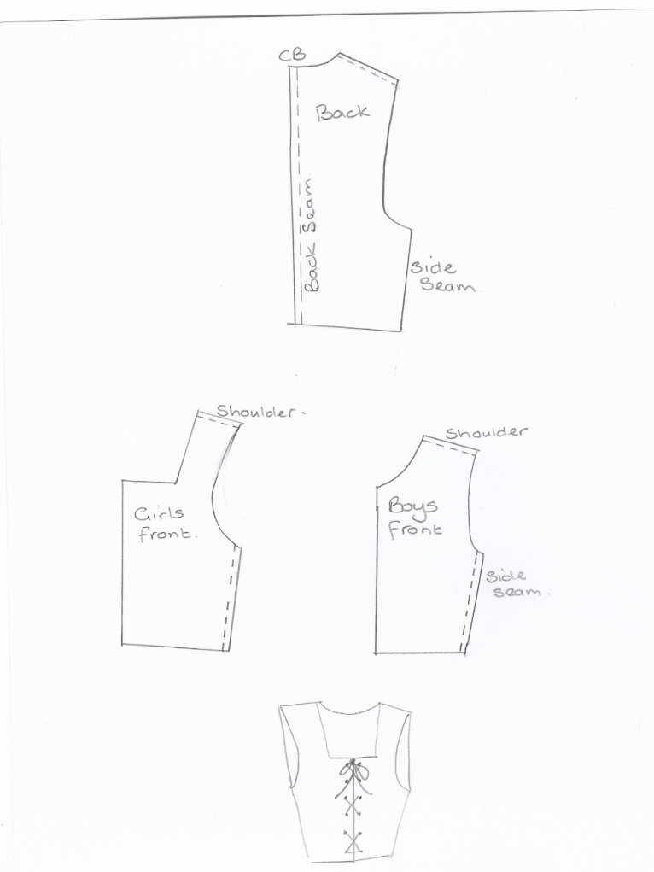

- Stitch along the back seams.

- Stitch the shoulder seams and the underarm seam.

- Add a front closure of a cord, as shown.

A separate skirt.
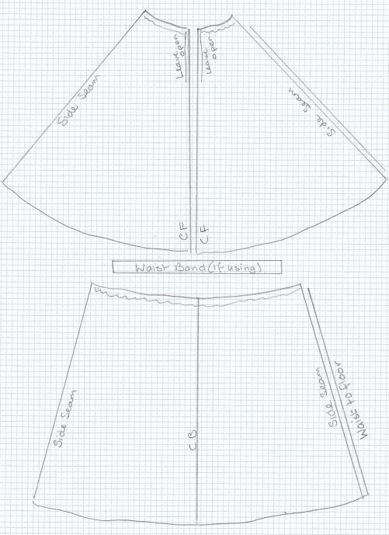
This can be as complicated as you wish. Leaving the front seam completely open allows you to have a pretty petticoat underneath. You will need to put on hooks or buttons to fasten it.
If you do not wish to use the plain tube skirt you can add a slightly flared skirt. This can be attached to the waistcoat or be a separate garment.

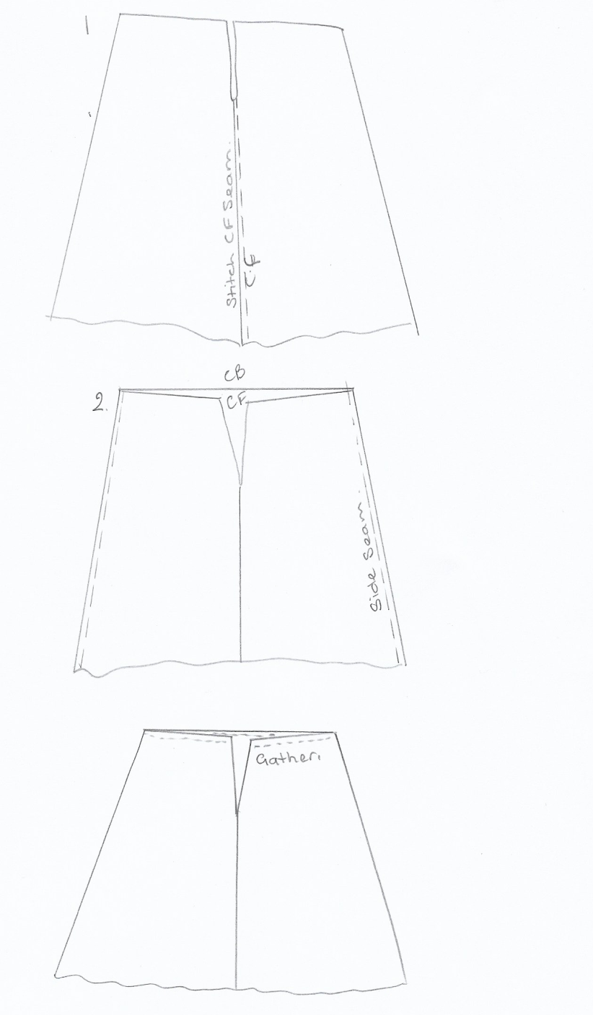
- Stitch the front seam but leave a vent to allow entry.

- Stitch side seams.

- Gather the top and pin to the bottom of the waist coat. Stitch in place.
- If you are making the skirt separate cut a waistband slightly longer than the waist measurement. Attach the waistband in the same way as you would do if you were attaching it to the waistcoat. If desired you could make the opening at the back in which don’t leave the top front open. If you wish to do this, stitch the front of the waistcoat ant leave the back open. As per the picture below.
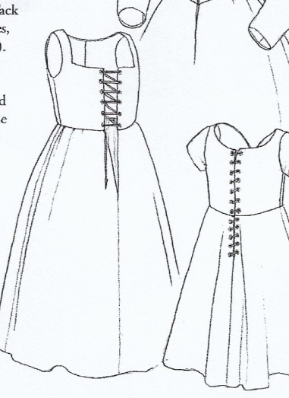
Picture shows the front and back opening.

Girls aprons.
This is just a rectangle of cloth. It is un-necessary to hem it, neither is it necessary to attach ties, unless you have made a dress, as it tucks neatly in to the waist band of the skirt.

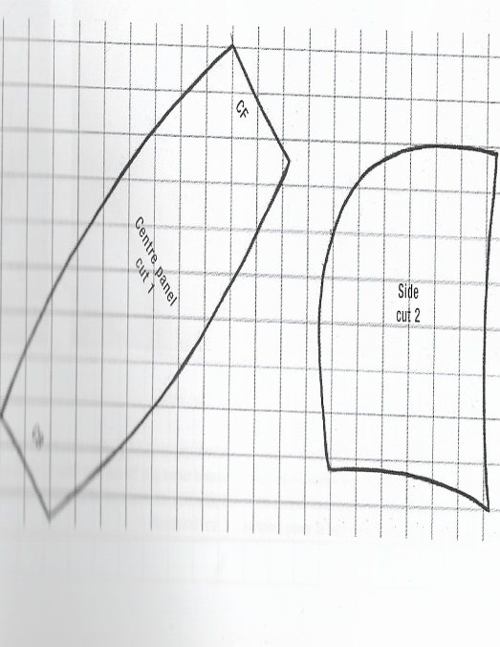
The boys coif.
This is two part shaped garment. It has a seam down the middle and ties to keep it on. (most boys including the older ones leave these undone.

The pattern piece to the right is the standard coif piece. If you need a larger coif then add the second piece between the two side pieces.
N.B you can also make one of these for a girl if the head wrap method is not working. They will need to have the ties and the hair should be confined at the back of the neck in a band/ponytail.

