Welcome to Suffolk County Music Service Remote Learning for WCET Classes.

**WCET Lesson 5 w/c 8 February 2021**

**[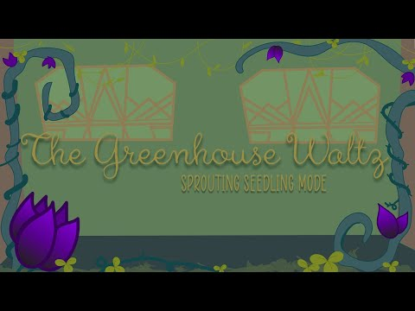](https://www.youtube.com/embed/uKoGio_g-wQ?feature=oembed)**Here are some musical activities for you to do at home or in school, and a new piece for you to learn to play on your instrument if you have it. If you don’t have your instrument, don’t worry! Listen to the piece instead and learn what it sounds like so that when you come back into school you can play with your class. Have fun!

[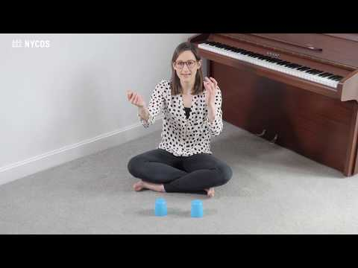](https://www.youtube.com/embed/f72un_Q-6c8?list=PLT03GmRKx8csYL171j4TQOWBrHcfwGoIA)Activity 1: **Try a cups pattern**

**in 3 time with NYCoS**

[Moses Supposes - YouTube](https://www.youtube.com/watch?v=f72un_Q-6c8&list=PLT03GmRKx8csYL171j4TQOWBrHcfwGoIA&index=21)

[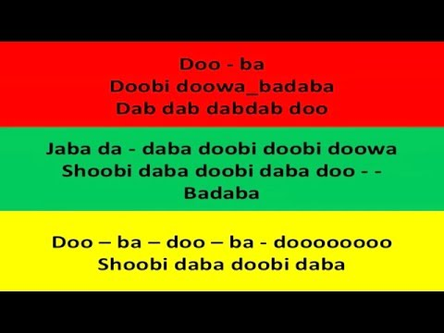](https://www.youtube.com/embed/OtYG_QPRfL0?feature=oembed) Activity 2: Rhythm play-along in 3 time with the Greenhouse Waltz (grab some wooden spoons, pencils, or chopsticks!). Now listen to ‘Moses Supposes’ again and try playing it, counting to 3, with your sticks instead of cups. [**Greenhouse Waltz You Tube link**](https://www.youtube.com/watch?v=uKoGio_g-wQ)

Activity 3: Listen,

Learn, Sing Swing! [Canon in Swing - YouTube](https://www.youtube.com/watch?v=OtYG_QPRfL0)

Activity 4: Here’s your piece for this week: If you don’t have your instrument, remember to listen, and learn the tune and rhythms anyway to play in class later. First do some warmups:

