Welcome to Suffolk County Music Service Remote Learning for WCET Classes.

**WCET Lesson 4 w/c 1 February 2021**

[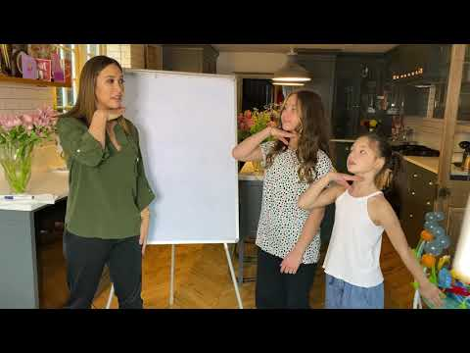](https://www.youtube.com/embed/8XXmBlTadys?feature=oembed)Here are some musical activities for you to do at home or in school, and a new piece for you to learn to play on your instrument if you have it. If you don’t have your instrument, don’t worry! Listen to the piece instead and learn what it sounds like so that when you come back into school you can play with your class. Have fun!

Activity 1: Learn how to turn your name

into a rhythm with Myleene Klass

[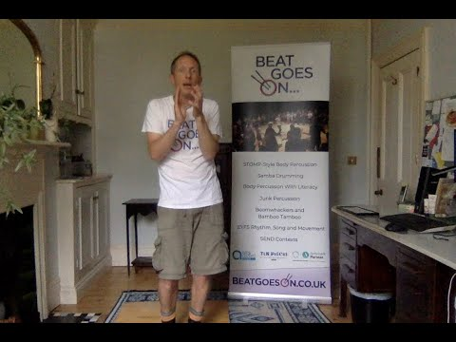](https://www.youtube.com/embed/leeyYjcrspU?feature=oembed) (ctrl + click on the link or click the picture)

[The one where we learn basic rhythms and then play your name - YouTube](https://www.youtube.com/watch?v=8XXmBlTadys) Activity 2: Turn your rhythm name into Body Percussion with Ollie Tumner

[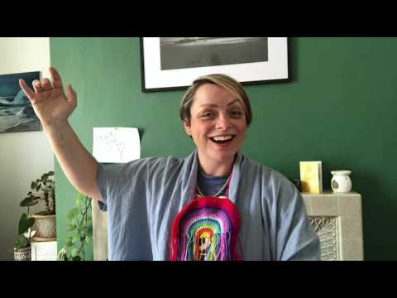](https://www.youtube.com/embed/tLdiAct3vEU?list=PL54cy6SoHBuIU_eNDmxl0twy86Ah5SNmR)Activity 3: Sing <https://www.youtube.com/watch?v=leeyYjcrspU>

Sing Up teaches ["I can see clearly now" - Learn the song with Beccy Owen - YouTube](https://www.youtube.com/watch?v=tLdiAct3vEU&list=PL54cy6SoHBuIU_eNDmxl0twy86Ah5SNmR&index=12)

Activity 4: Here’s your piece for this week:

