A Monster Calls ~ Writing activities
ALL activities to be handwritten making sure you remember your capital letters, apostrophes and check your spellings. I expect a high standard of presentation – please use a black handwriting pen.
Monday – Subjunctive Form and the Power of Three: Explore adjectives to describe the monster’s outstretched hand: gnarled, twisted, knotted, twig-like, spindly, moss-ridden. Try to come up with some of your own words.
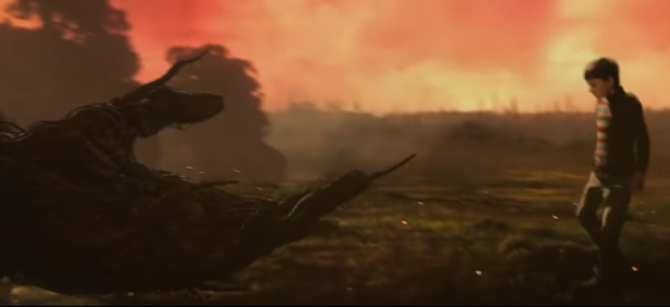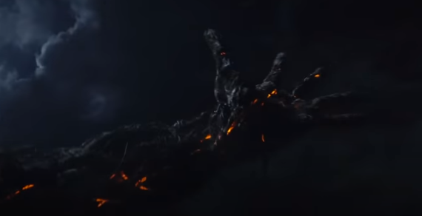
Next, think about some “If I were…” subjunctive phrases that Conor might say to the monster. For example: “If I were to leave my bedroom…” “If I were to trust you…” “If I were to believe you…”
The monster lowered its gnarled twig-like hand. “COME WITH ME!” it bellowed.
Conor replied, “If I were to put myself in your hands, if I were to go with you, if I were to trust you, then what would you offer me?”
Using this model, write your own sentences that include the subjunctive form “If I were…”. You must use the structure of my sentence and can change the adjectives to describe the monster’s hand to make the sentences your own.

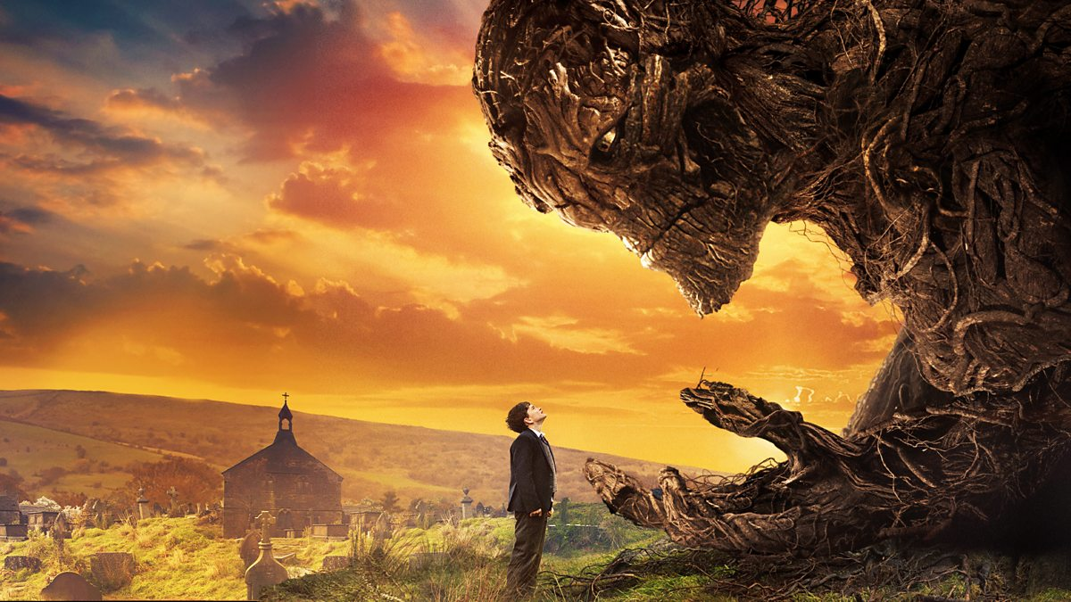
Tuesday – Conor’s Meeting with the Monster using dialogue:
Imagine you are Conor – you are not scared by the monster despite its best efforts to threaten and intimidate you. Think about your body language and what you might say to the monster – you are nonchalant and unaffected by the monster’s shouting and threats.
Powerful verbs for ‘said’ | ‘nonchalant’ words
bellowed thundered  howled snarled  growled roared | casually unaffected  unconcerned indifferent  unmoved detached

Using this model, write at least two of your own dialogue sentences that follow the structure and use some of the words in the grid above:
“I have come to get you, Conor O’Malley,” thundered the monster.
“I’ll do what I want,” answered Conor casually.

Thursday – Using action and personification: Using the images below from the trailer when the monster was using violent action, come up with some ‘violent verbs’: roared, ripped, twisted, throttled, strangled, pummelled, tore, yanked.
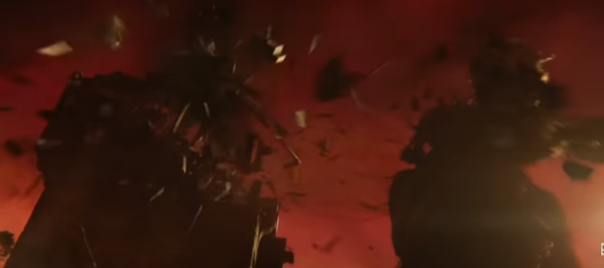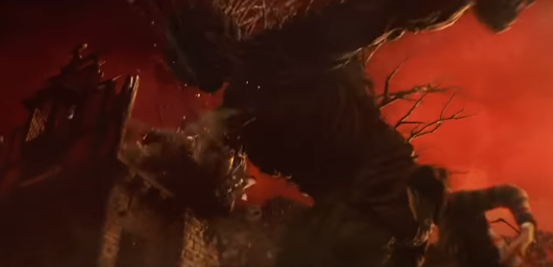
Stomping across the soil, the monster strangled clouds, tore at trees and pummelled brickwork.
Use the model above to write at least two of your own sentences that have three of the monster’s violent pieces of environmental destruction. You could also change the verb ‘stomping’ to one of your own.
Now think of some words to describe human fear responses to the monster’s violent actions: trembling, sweating, shivering, quaking, shaking.
Use the model below to personify the inanimate objects’ reactions to the monster’s rampage. Use the same three objects as you have in your ‘action’ sentences.
The clouds hid behind the moon, the trees trembled and the bricks shuddered in fear.

Friday – Synonyms, repetition, actions + subordinating conjunctions: Today is the last ‘Sentence Stacking’ lesson and you will be coming up with three different sentences using my models.
Synonyms + repetition: A real monster. An enormous real monster. An enormous, angry real monster.
Synonyms for ‘enormous’ | Synonyms for ‘angry’ | Synonyms for ‘real’
colossal huge  gigantic vast  towering enormous | irate enraged  furious incensed  fuming infuriated | genuine authentic  actual proper  bona fide
Choose alternative adjectives for ‘real’, ‘enormous’ and ‘angry’ to come up with your own sentence that includes repetition.
Actions: Shrugging his shoulders, yawning nonchalantly and learning on the windowsill, Conor watched the monster.
How could you show that Conor isn’t scared? Here are some example phrases:
- shrugging his shoulders
- turning his back
- smiling wryly
- yawning nonchalantly
- rolling his eyes casually
Think of some more phrases and choose three to write a sentence that shows Conor is completely unmoved by the monster’s actions.
Subordinating Conjunctions: Despite the monster’s aggressive, threatening presence, Conor felt no fear.
“Shout all you want,” Conor shrugged, barely raising his voice, “I’ve seen worse.”
Here are some subordinating conjunctions: despite, since, in spite of, although, even though, in the face of, regardless of, even after, undeterred by
Choose a subordinating conjunction instead of ‘despite’ to open your sentence; then follow with dialogue that emphasises Conor’s unflappable stance. Change the two adjectives highlighted in green to make the sentence your own. The dialogue highlighted in grey can stay the same as this is directly from the book.

YOU WILL NOW NEED TO KEEP ALL OF THE SENTENCES THAT YOU HAVE CREATED OVER THE LAST THREE WEEKS FOR YOUR OWN GUIDED STORY.
A Monster Calls – Teacher Model
Conor had a nightmare: the horrifying, howling wind; a torturous trickle of blood; sudden, short breaths; and a sinister, shadowy figure. He woke. He woke gasping. He woke trembling. Only semi-conscious, Conor sat up in bed. ‘What was that?’ he thought. Something was unfamiliar… something was different… something was very unfamiliar and very different.
12:07. Seven minutes past midnight. For Conor, time dragged desperately as his heart pounded in his chest. It was beating twice as fast as the ticking clock. Emerging from the darkness was his familiar teddy bear, his comforting duvet and the reassuring clicking of his radiator. Conor, who had leaned closer to the edge of his bed, looked back at the frozen clock.
The light of the moon cut through the darkness. The magnetic moon beckoned Conor. Shadows lingered in the garden – sinister, threatening.
Crash! The earth ripped. Thud! The soil parted. Boom! The terrain tore.
“Am I still in my nightmare?” thought Conor to himself calmly. Piercing from the depths were eyes as red as fresh embers. Conor watched as the tree emerged from the ground. Twigs tangled, roots wrenched and leaves laced to form the monster of his nightmares. Conor stared out at the beast. The monster lowered its gnarled twig-like hand.
“COME WITH ME!” it bellowed.
Conor said, “If I were to put myself in your hands, if I were to go with you, if I were to trust you, then what would you offer me?”
“I have come to get you Conor O’Malley,” thundered the monster.
“I’ll do what I want,” said Conor casually.
Stomping across the soil, the monster strangled clouds, tore at trees and pummelled brickwork. The clouds hid behind the moon, the trees trembled and the bricks shuddered in fear.
A real monster. An enormous real monster. An enormous, angry real monster. Shrugging his shoulders, yawning nonchalantly and leaning on the windowsill, Conor watched the monster. Despite the monster’s aggressive, threatening presence, Conor felt no fear.
“Shout all you want,” Conor shrugged, barely raising his voice. “I’ve seen worse.”

