A Monster Calls ~ Writing activities
ALL activities to be handwritten making sure you remember your capital letters, apostrophes and check your spellings. I expect a high standard of presentation – please use a black handwriting pen.
Monday – Adjectives in unusual Positions: Look at these images of a garden at night. Use these pictures to mindmap adjectives to describe them. Some adjectives to get you started: dark, scary, eerie, sinister, ink-black, mysterious, ominous, foreboding, threatening.
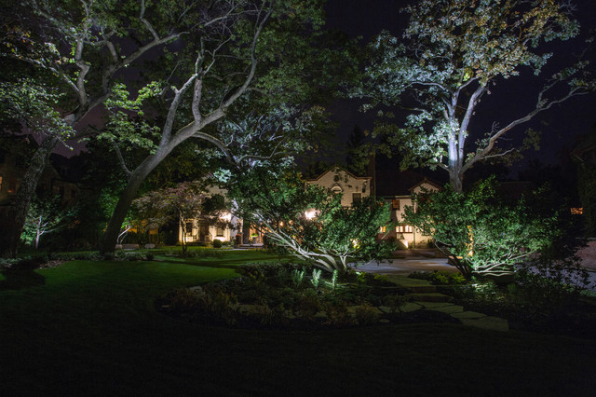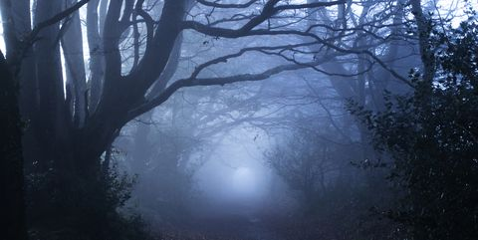
Shadows lingered in the garden – sinister, threatening.
Using this model, write at least two of your own sentences that include a dash (to create a pause for effect) and then two adjectives. You must use the structure of my sentence and can change the verb ‘lingered’ to make the sentences your own.
Now choose three adjectives after the dash and add in an adverb to describe the verb you choose instead of ‘lingered’.
Tuesday – Onomatopoeia and short, effective sentences: Add some more onomatopoeic words and destructive verbs to the table below this picture.
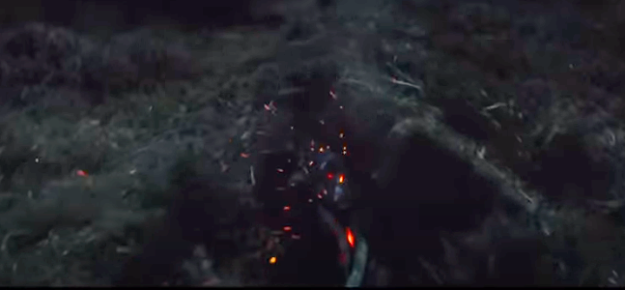
Onomatopoeic Words | Destructive Verbs
thud thump  crash bang  boom smash | ripped tore  parted exploded  wrenched cracked

Using this model, write at least two of your own sentences that follow the structure: onomatopoeic word, destructive verb. In each sentence, you need three of each – you could reuse some of the words in your second sentence but in a different order.
Crash! The earth ripped. Thud! The soil parted. Boom! The terrain tore.
Thursday – Using dialogue and Similes: As the monster appears, what might Conor be thinking to himself? For example: What is this? How can this be happening? Am I still in my nightmare?
In the first chapter, when Conor first meets the monster, he is not scared. The following words could be used to identify Conor’s calm reaction to the monster: calm, cool, composed, unfazed, indifferent, nonchalant. You could add more of your own.
“Am I still in my nightmare?” Conor thought to himself calmly.
Use this model to write at least two of your own sentences that have dialogue and one of the reaction words.
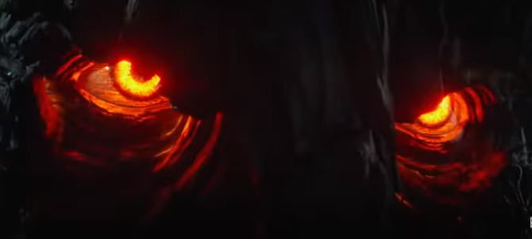
Synonyms for red: blood, fire, lava, volcano, burning, flaming, glowing.
Piercing from the depths were eyes as red as fresh embers.
Use this model and the synonyms for red to build at least two of your own red similes.

Tree parts | Powerful Verbs
roots moss  trunk needles  twig bark  branches  fingers leaves | ripped tore creaked  tangled  wrenched cracked
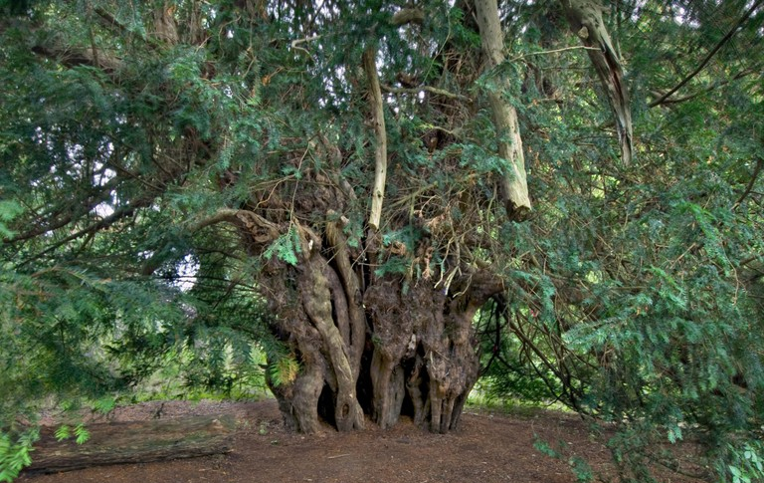
Friday – Alliteration and Synonyms:

Use the words in the grid above (you can think of your own – or use a thesaurus) and the model below to write at least two alliterative sentences about the tree monster.
Twigs tangled, roots wrenched and leaves laced to form the monster of his nightmares.
Synonyms for ‘look’ | Synonyms for ‘monster’
glanced stared  peeped studied  scanned peered  ogled examined | beast demon  creature  ogre fiend  giant brute
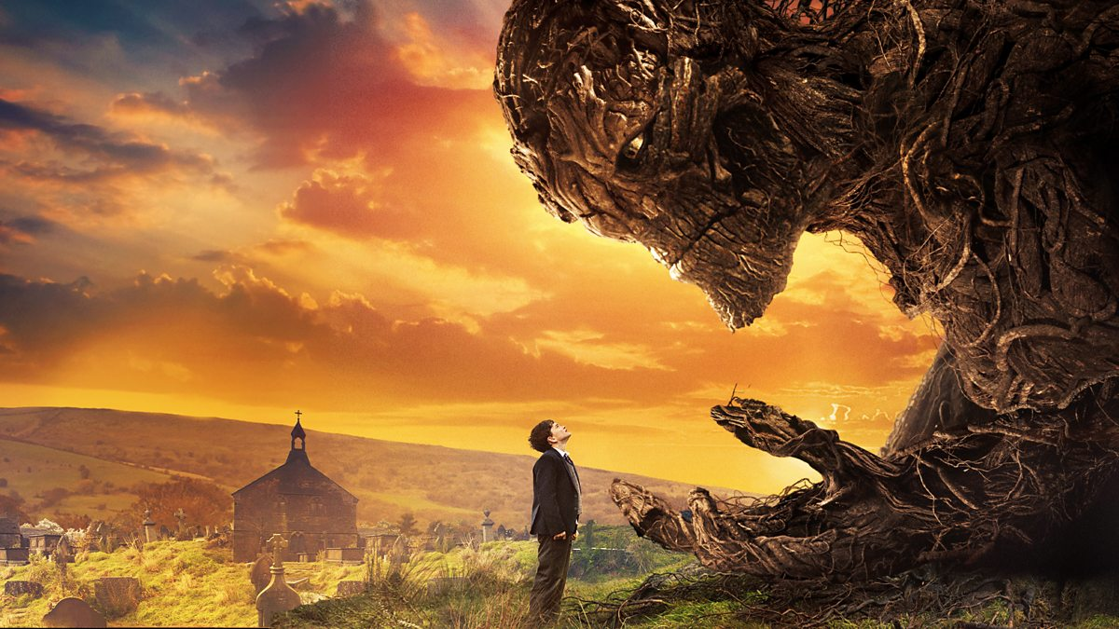

Use the words in the grid above (you can think of your own – or use a thesaurus) and the model below to write at least two sentences about Conor looking at the monster.
Conor stared at the beast.

