Communication: Emojis, Text-talk and Phishing
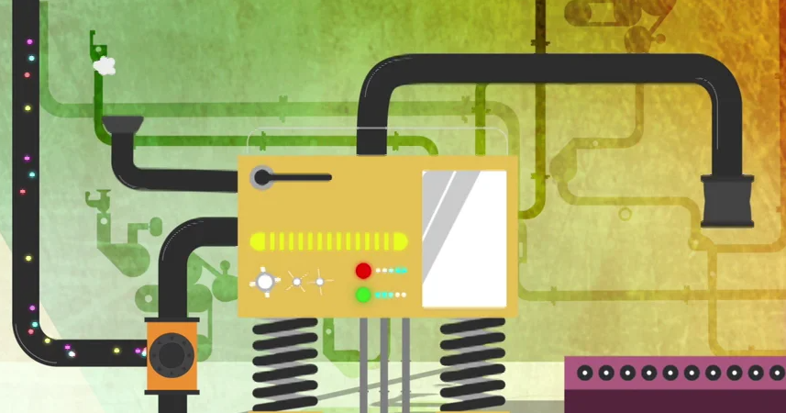
Watch this video and note down what the video is about. Now make a list of all the things you can do online and what you can use to access the internet. Remember, these things have only been around for a matter of years, but that they can make our lives much easier and give us access to incredible means of communication and information.
Watch this video about how technology and the internet continue to enable greater efficiency in our world. We can describe this as an ‘online world’ as opposed to the real world.

As you know, it is important to keep ourselves safe in the real world as well as the ‘online world’. For example, would you leave your front door open all night, walk alone in an isolated place for several hours without telling anyone where you were going or find the nearest stranger in the park and ask them to come home for a drink? You may find these things ridiculous, but we find identifying ways of staying safe in the ‘real’ world far easier than translating it into the online world.
Over the next couple of sessions, you are going to become experts in online e-safety and create either an online quiz or a board game for yourself and others (in Foxes Class) to see if you are Citizen e-safe or Citizen not-so-safe.
Today you will be creating the ‘communication’ section of your quiz. There are many different ways that we can communicate ideas, a message or information online: Facebook, Instagram, Snapchat, Twitter, email, text, WhatsApp etc… and we can communicate in whole words, images, emojis and abbreviations/text speak. Remember, many apps have age restrictions so you and your adults at home must be aware of these.
Think about which one you might use to communicate to a friend or parent. Would you use the same means of communication for someone more formal? Sometimes people use Twitter to communicate directly with people or organisations (e.g. highlighting a train service delay), and that this may elicit a response that will potentially be of interest and use to lots of people, unlike a text that informs only the recipient.
You will complete three challenges in which you will explore online communication with a view to coming up with a max of five questions for your quiz or board game
Challenge one: Choose a different colour or symbol for each form of communication:
- Text
Formal purposes
- Email
- Twitter
Chatting and sharing with others
- Facebook
- Instagram/Kudos
Functional purposes
- WhatsApp
- Snapchat
- Viber/Messenger
- Skype/phone calls

Use the Venn diagram to show how you might use these forms of communication for:
- Formal purposes (e.g. making a complaint)
- Functional purposes (e.g. making arrangements to meet)
- Chatting and sharing with friends
One recipient

Now use the Venn diagram to show how many of these forms of communication could be for:
- One recipient
- 2-3 recipients
2-3 recipients
- Multiple recipients

Read the emails, texts, snapchats and tweets about to be sent:
Multiple recipients
Can you spot the good ones that will get the message across clearly without causing offence or confusion?
Are there others that might be misinterpreted, cause a negative reaction, or upset someone?
What might happen if you sent these communications without thinking about how they might come across?
WhatsApp: A friend has texted/messaged to ask if you and another couple of friends would like to meet up. You are in the middle of something and can’t make an arrangement at that moment. Possible responses:
- Am busy – text later
- Having a ‘mare at mo! Let me know where you end up
- Not now
- Can I let you know in a bit? Currently surrounded by paint, LOL!
Email: You emailed a company to make a complaint recently about a faulty item of clothing. They responded by suggesting you take the item back to a shop (which is not possible) or return it by post (at your own cost). Possible responses:
- I will not pay for return postage – this is not acceptable. I will make sure that I tell my friends not to shop with you as this is rubbish customer service. Please refund my money immediately or I will take this further.
- Thank you for your email. I am unable to return the item to a shop, and am a little disappointed that I am expected to pay for return postage on a faulty item. Would it be possible for the postage to be refunded along with the money for the item itself? I would be very appreciative if you could let me know before I send the item back.
Kind regards
Social network status (e.g. Facebook): You cancel going to a friend’s house as you feel unwell. A bit later, feeling better, you head out to the park and take a ‘selfie’ that you want to post online. The friend you cancelled on is a Facebook friend. Possible outcomes:
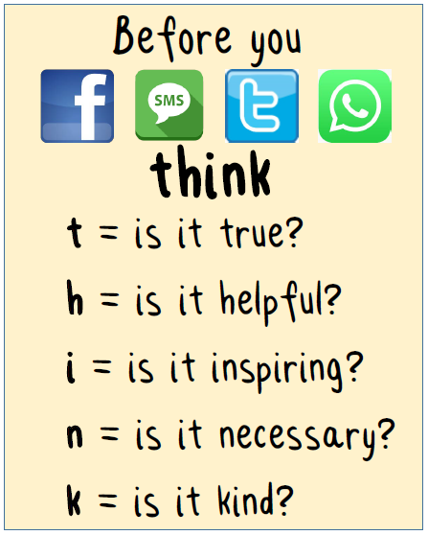
- You post the selfie online with a caption ‘feeling a bit better – sorry I missed out on catching up with (tagging your friend)’
- You post the selfie online with no caption
- You post the selfie online with the caption ‘great afternoon in the park’
- You do not post the selfie online
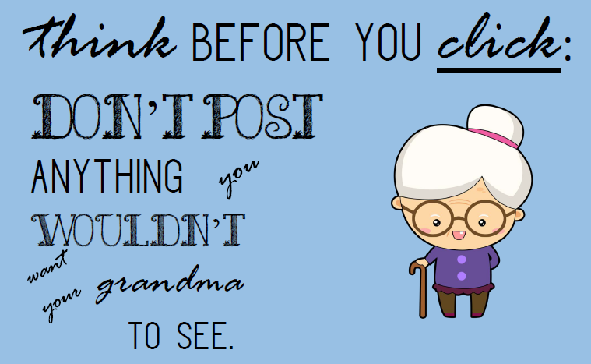

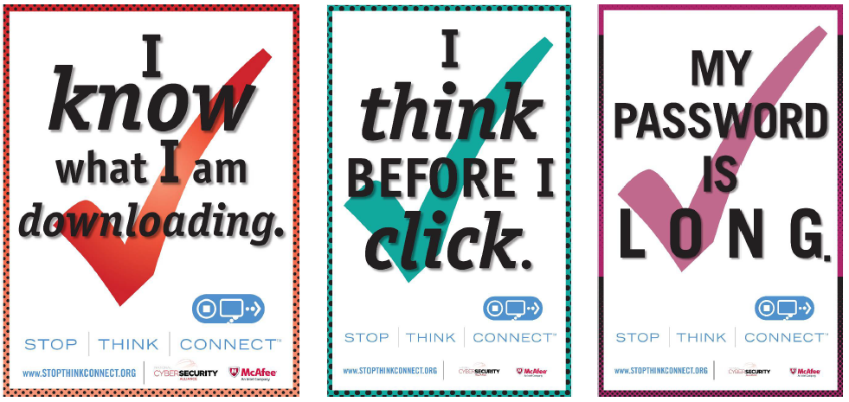
Look at the posters - why do people need to remind themselves to think before sending or clicking?
Can you come up with 1-2 quiz questions for ‘think before you send’?

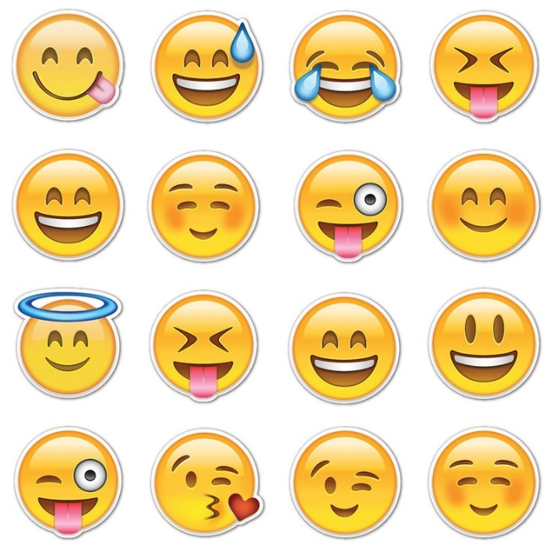
Challenge two: Look at the given emojis and text-talk abbreviations and come up with 1-2 words to describe what the emojis might mean, and what you think the text-talk/abbreviations mean.
Text-talk/abbreviations:
LOL
SYS
BTW
JK
TTFN
RUOK
Think about the following questions:
- Do you all think they mean exactly the same thing?
- Do you think older/younger people they know understand emojis and text-talk/abbreviations in the same way as you do?
Now look at the how the ‘grimacing face’ emoji changes from one system to another:
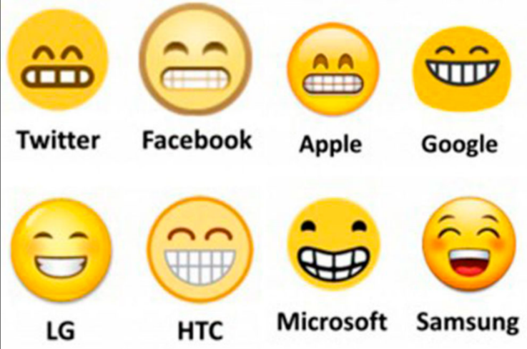
- Do you think the meaning of them has changed?
- What do you think you should consider when quickly sending emojis or using text-talk to people?
Can you come up with 1-2 quiz questions for ‘using emojis and text-talk’?

Challenge three: Read the emails and decide which ones you think are for real and which ones are ‘phishing’ (fake)?
Dear User,
You Will be blocked from sending and receiving emails if not confirmed within 24hrs of receiving this automated mail. You are required to update through the link below.
UPDATE LINK
Thanks for using Yahoo
YAHOO Team
Dear Chloe

Please find attached your invoice for your latest iTunes transactions. If you did not make these purchases or are concerned that your account may have been compromised, please follow this link and log in to your account.

Apple inc
Dear Mr Castle
Your postcode is: N93 6SW

We'll always include your postcode at the top of emails we send so you know it's from us. If you notice that your postcode is wrong you can update it via Internet Bank or by visiting your local branch. Your updated postcode will show on emails sent from us within 8 weeks.

We never ask for confidential details or security information in our emails. If you're ever suspicious of an email, please delete it immediately. If you think you've revealed your personal or security details visit our security web page here.

The Nationwide Banking team
Check the answers (on the next page) and consider:
- What might a phishing email be trying to get you to do?
- What do you think you should do if you receive a phishing message?
Can you suggest a list of clues that might identify a phishing email – one that is not genuine and that we shouldn’t open or take notice of?
Can you come up with 1-2 quiz questions for ‘phishing messages’?

Fake or phishing emails – ANSWERS
(the first and third emails were phishing while the middle one was legitimate)
Fake emails often (but not always) display some of the following characteristics:
- The sender’s email address doesn’t tally with the trusted organisation’s
website address
- The email is sent from a completely different address or a free web mail address
- The email does not use your proper name, but uses a non-specific greeting like “dear customer” or your username
- A sense of urgency, e.g. the threat that unless you act immediately your account may be closed
- A prominent website link. These can be forged or seem very similar to the proper address, but even a single character’s difference means a different website, and the shown ‘descriptor’ of the weblink is not necessarily where it actually links to (you can tell if you hover over the link)
- A request for personal information such as user name, password or bank details
- The email contains spelling and grammatical errors
- You weren't expecting to get an email from the company that appears to have
sent it
- The entire text of the email is contained within an image rather than the usual text format
- The image contains an embedded hyperlink to a bogus site
- An attachment that you are asked to open immediately
You can report phishing emails using this website: www.actionfraud.police.uk/scam-emails
What you think you should do if you come across one?
(Not open it, tell a trusted adult, get someone to help you to report it.)

