Welcome to Suffolk County Music Service Remote Learning for WCET Classes.

**WCET Lesson 2 w/c 18 January 2021**

Here are some musical activities for you to do at home or in school, and a new piece for you to learn to play on your instrument if you have it. If you don’t have your instrument, don’t worry! Listen to the piece instead and learn what it sounds like so that when you come back into school you can play with your class. Have fun!

[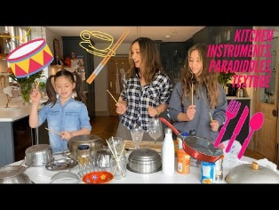](https://www.youtube.com/embed/hA2Z-GVNdxo?feature=oembed)Activity 1: Wake up with some rhythm work. Follow this link to see what it is: (ctrl + click on the link or click the picture) [The one where we make our own instruments and learn to drum! - YouTube](https://www.youtube.com/watch?v=hA2Z-GVNdxo)

[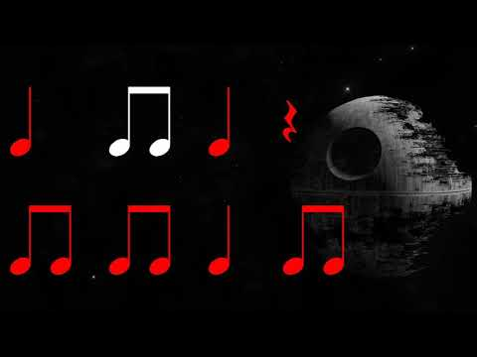](https://www.youtube.com/embed/SbPrMrqPW88?feature=oembed)Activity 2: Use kitchen instruments to play along to the ‘Star Wars’ theme using rhythm notation. [Star Wars Theme Song Rhythm Video- Level 2 - YouTube](https://www.youtube.com/watch?v=SbPrMrqPW88)

[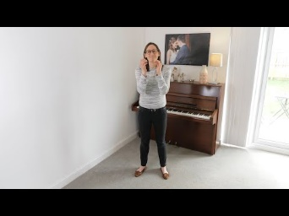](https://www.youtube.com/embed/4-XImQ0xNWI?list=PLT03GmRKx8csYL171j4TQOWBrHcfwGoIA)Activity 3: Wake your voice and body up with a song

[Senua De Dende - YouTube](https://www.youtube.com/watch?v=4-XImQ0xNWI&list=PLT03GmRKx8csYL171j4TQOWBrHcfwGoIA)

Activity 4: Here’s your piece for this week:

