A Monster Calls ~ Writing activities
ALL activities to be handwritten making sure you remember your capital letters, apostrophes and check your spellings. I expect a high standard of presentation – please use a black handwriting pen.
Monday – Time Clues: Imagine all the time sounds that there might be: clock ticking, chiming, bell.
You are going to write sentences that include time clues. 12:07am. Seven minutes past midnight.
For Conor, time dragged desperately as his heart pounded in his chest. It was beating twice as fast as the ticking clock.
Using this model, write at least two of your own sentences that include time clues.
Tuesday – Complex Sentences: You will need to go into your bedroom to complete this activity! Climb into your bed (yes, you’re allowed) and look around at what’s in your room. What is it in your room that makes you feel comfortable and safe?
Find just two things and write down what they are and why they make you feel like this.
Now come up with some familiar bedroom sounds: heating clicking off/on, rustling of the bedding, clock ticking, a sibling snoring, an adult rattling around in the kitchen downstairs.
Using this model, write at least two of your own sentences that begin with an ‘ing’ verb and including your own bedroom objects.
Emerging from the darkness was his familiar teddy bear, his comforting duvet and the reassuring clicking of his radiator.
Thursday – Relative Clauses: Conor looked back at the clock that had not changed.

Relative clauses can begin with who/whose. Think of some clauses for a sentence about Conor looking at the clock: …who was thinking about school; …whose eyes were slowly peeling open; …who felt frustrated;
Conor, who had leaned closer to the edge of his bed, looked back at the frozen clock.
Use this model to write at least two of your own sentences that have an embedded relative clause (mine is highlighted in yellow) and are about Conor looking at the clock.
Friday – Personification and Alliteration: Look at this image of a moonbeam cutting through a window.
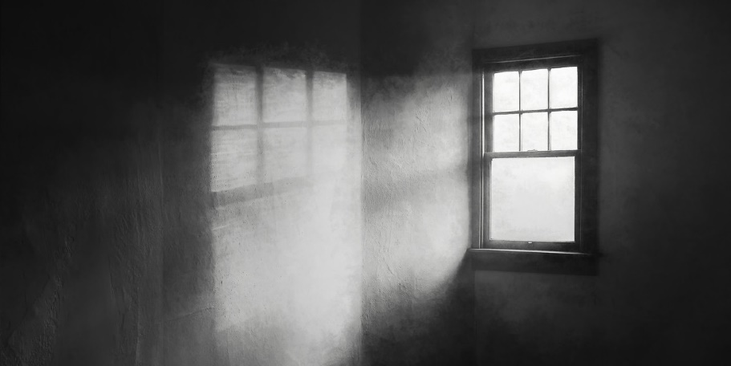Think of some synonyms for ‘cutting’ – sliced, carved, pierced, stabbed, penetrated. Use this model and synonyms for ‘cutting’ to write a sentence to describe the action of the moon cutting through the darkness: The light of the moon cut through the darkness.
Alliterative adjectives for the moon | Verbs for the lure of the moon
mesmerising magnetic  magical magnificent  monumental marvellous | pulled hypnotised  tempted beckoned  dragged drew  enticed
The magnetic moon beckoned Conor.
Use the words in the grid above (you can think of your own – or use a thesaurus) and the model to write at least two sentences that describe the lure of the moon.

