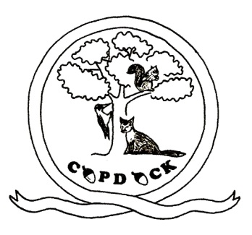
Copdock Primary School
School Hill, Copdock,

Ipswich, Suffolk
IP8 3HY
Telephone / Fax : 01473 730337
E-mail : admin@copdock.suffolk.sch.uk

Headteacher: J Austin
Web: www.copdock.suffolk.sch.uk

September 2022
School Uniform Order Form

Child’s Name…………………………..………………………………………… Class……………………………………………

Item | £ | 3-4  (24”) | 5-6  (26”) | 7-8  (28”) | 9-10  (30”) | 11-12  (32”) | 13  (34”) | Total cost
Crew neck sweatshirt, with crest | £10.00
Sweat cardigan, with crest | £11.00
Tee shirt, with crest | £5.10
Shower proof jacket, with crest | £20.30
Polar fleece, with crest | £13.50
 |  | One size only
Knitted winter hat, with “Copdock” | £5.00
Summer hat, with flap & “Copdock” | £5.00
Book Bag, with crest | £5.50
PE rucksack, with crest | £5.50
All items are Royal Blue, except tee shirts which are white. Total cost

Cash or Cheques payment included with order (made payable to “Copdock Primary School”)
School spider payment method .
Please tick payment method above
PLEASE SEND INTO THE OFFICE BY Monday 10th October 2022

Signed……………………………………………………………………………………………………………Date ……………………………..

