Home learning during school closure or self-isolation Kittens (Reception)
Summer Term 2 – Week Beginning: 6.7.20
 | Monday | Tuesday | Wednesday | Thursday | Friday
Maths | Investigations:  Patterns and Ordinal Numbers  Explore different patterns and ordinal numbers – click here  Resources:  -Activity sheet – see Monday blog  -3 different coloured pens | Number Investigations:  Find different ways of making 4 and 6 – click here  See Monday blog for part-part-whole sheet.  Resources:  -Activity sheet – see blog | Number Investigations:  Number combinations  Find different number combinations – click here  Resources:  -Number cards to 10 or 20  -10 or 20 objects for counting/arranging | Number Investigations:  Which numbers are odd and which are even?  Using digit cards make a number line 1 -10. For each number, collect that number of objects. E.g. 2. Split the 2 objects into 2 containers. Is the sharing fair? Do the containers have the same? If so, the number is even – it’s fair. Repeat for all numbers 1-10. Which are odd, which are even? Sort accordingly.  Resources:  -Digit cards 1-10  -10 counting objects  -Labels – odd / even | Investigations - Hidden Gems:  Click here for activity.  Can you say the total without counting the objects?  Resources:  -Objects to represent gems  -3 continuers
Writing | Download Brian Bear booklet.  Read the story on page 3 and 4 and complete page 12 (design a picnic rug) Can you write a list of things on your design?  E.g. red dots  green stripes  yellow stars | Reread Brian Bear on page 3 and 4 and complete page 13 (write a thank you letter) | Reread Brian Bear on page 3 and 4 and do page 16. Write about the special things you find on a walk either a list or simple sentences e.g. First I see a small leaf. Next I see a brown twig. | Reread Brian Bear on page 3 and 4 and do page 17 (history of the Teddy Bear ) | Reread Brian Bear on page 3 and 4 and complete page 18 (make a bear mask and make up your own adventure)
Reading | Listen to audio version of Brian Bear here | Listen to Hey! Get off our Train. Ask your child to order the events from the story using simple sentences, illustrations or both. | Choose a book from Oxford Owl  Login = WSR12 password = bcps  Storytime – see attached PDF on blog page | Look through a newspaper or magazine and list the different types of transport found. Record these in a table.  Storytime – see attached PDF on blog page | Choose a book from Oxford Owl  Login = WSR12 password = bcps  Storytime – see attached PDF on blog page
Spellings/  phonics  . | Continue to use teach your monster to read.  www.teachyourmonst  ertoread.com  (free to set up an account on laptop/home computer)  Phase 4: Adjacent consonants  Lesson 36 – click here  Follow up sound using games on Phonics Play:  https://new.phonicsplay.co.uk/ | Continue to use teach your monster to read.  www.teachyourmonst  ertoread.com  (free to set up an account on laptop/home computer)  Phase 4: Adjacent consonants  Lesson 37 – click here  Follow up sound using games on Phonics Play:  https://new.phonicsplay.co.uk/ | Continue to use teach your monster to read.  www.teachyourmonst  ertoread.com  (free to set up an account on laptop/home computer)  Phase 4: longer words  Lesson 38 – click here  Follow up sound using games on  Phonics Play:  https://new.phonicsplay.co.uk/ | Continue to use teach your monster to read.  www.teachyourmonst  ertoread.com  (free to set up an account on laptop/home computer)  Phase 4: longer words  Lesson 39 – click here  Follow up sound using games on Phonics Play:  https://new.phonicsplay.co.uk/ | Continue to use teach your monster to read.  www.teachyourmonst  ertoread.com  (free to set up an account on laptop/home computer)  Phase 4: longer words  Lesson 40 – click here  Follow up sound using games on Phonics Play:  https://new.phonicsplay.co.uk/
Topic  Music  PSHE  Art | Look at the video clip – How do planes work?  Make Paper Planes  Make paper airplanes using this guide. Ask your child/ children to come up with a name for their airplane and write this on the side. Have a competition to see whose airplane will fly the furthest/ highest. You could ask them to create a certificate for the winner. | Origami Boat  Follow the instructions here to make your very own origami boat. You could float these in a paddling pool, in the sink or in the bath. Experiment with filling your boats up with objects, does it still float?  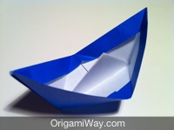 | ART  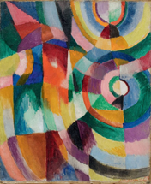  Wacky Wheels- Cut out a circle from an old cardboard box. Ask your child to create a wheel print using this template and paint. If you do not have paint, your child could draw around the circle and create a repeating pattern. Look at this Sonia Delaunay print for inspiration. | PSHE: Coping with emotions in change situations – end of unit  What animals can you think of which demonstrate change, e.g. a caterpillar becoming a butterfly; a tadpole becoming a frog; a chameleon changing colour; a chick hatching out of an egg.  What changes have we been talking about in this unit, e.g. moving house, new baby, family change, friendship change, losing something, starting something new etc.  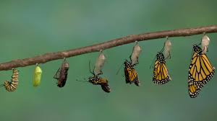  Think of someone you know who is facing a change at the moment and make a card for them, maybe adding a message you have learned during this unit. You could use the animals you have talked about to decorate the card. | Design and Technology  Moving Models- With your child find some junk modelling around the house and support them make a model car that moves or use Lego. Test it out in the garden or during your daily walk. Does the car move faster or slower on a ramp? Why/why not?  Take a look at these online resources from the transport museum to help you.  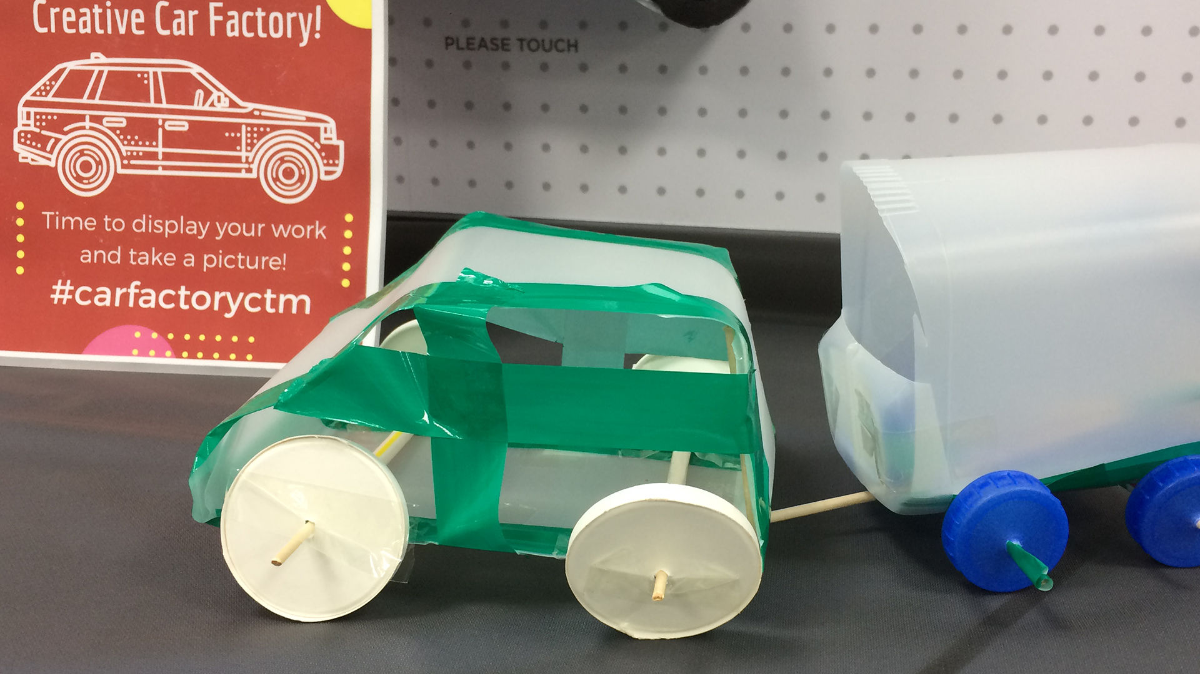

Other suggestions for afternoon activities:
Traffic Lights
- Play the traffic light game- Ask your child to help create a set of traffic lights. This could be as detailed or simple as you like. Ask your child to run around the garden/ outdoor space. When you point to a colour on the traffic light they have to do the following:
  - Red- Stop or freeze where they are
  - Orange- Walk slowly
  - Green- Run
You can extend this by adding in different colours or actions e.g. when you bounce a ball on the ground, they have to jump up and down.
Follow the instructions -
- Give instructions to guide each other around the house/garden i.e. forward two steps, turn left, forward two more steps.
- Can you support your child in drawing a map to show the way around the house? CHALLENGE: Work with your child guiding Bee Bot to the flower. Use the arrows and press ‘Go!’

Learn to Ride a Bike-
- Support your child in learning to ride a bike. They could even do an obstacle course to help develop their control or have races to improve their speed.

Brilliant Boats
- Collect different materials from around your house. Paper, yoghurt pots, cereal boxes, tinfoil cake tins. Which objects make the best boats? Which boat will carry the most coins or marbles?

PE Links
- PE with Joe Wicks every morning at 9am - www.youtube.com/channel/UCAxW1XT0iEJo0TYlRfn6rYQ
- Go Noodle, lots of fun dance resources - https://www.gonoodle.com/
- Youth Sport Trust have a range of resources to keep you active that you can access for free:
- Activity cards - www.youthsporttrust.org/pe-home-learning
- Active breaks - www.youthsporttrust.org/active-breaks
- 60 second challenge physical activity cards - www.youthsporttrust.org/60-second-physical-activity-challenges
- Cosmic Yoga - www.cosmickids.com/category/watch/ and use your print out of yoga moves.
- Create a circuit in your garden.

Collective Worship links:
https://www.thenational.academy/assembly
https://www.cofeguildford.org.uk/education/christian-distinctiveness/collective-worship/covid-19-resources
Open the Book video of Down through the roof Video I Don’s Introduction, Video 2 Jane and Peter telling the story, Video 3 Don’s reflection about the story, Video 4 Peter’s prayer.
Open the Book video of Jesus and the children Video 1 Carolyn’s introduction, Video 2 Jane and Peter telling the story, Video 3 Carolyn’s reflection on the story.

