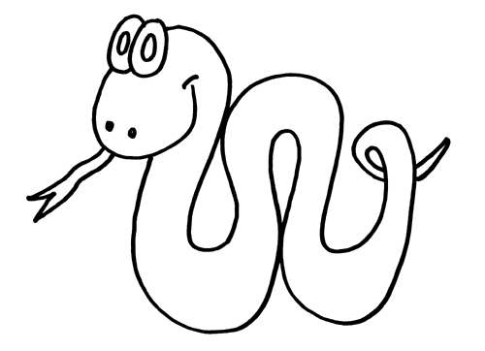
Choose 3 different colours and colour your snake in a repeating pattern.
What colour is the:

1st stripe last stripe

4th stripe 8th stripe

