Answers Tuesday 19th May
Year 5 Maths – Translations with co-ordinates
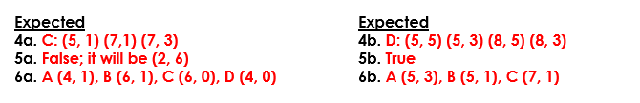
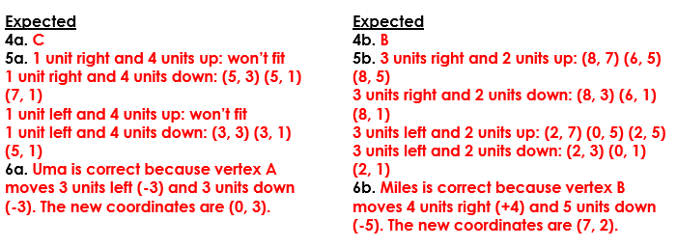
Year 6 Maths – Reflections
