Answers Monday 16th May
Maths year 5 – Translations

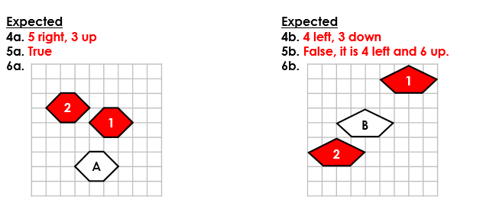
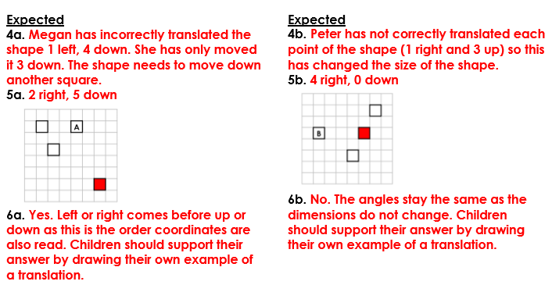
Year 6 maths – Translations

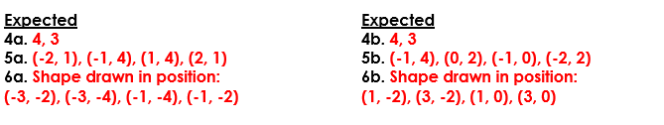
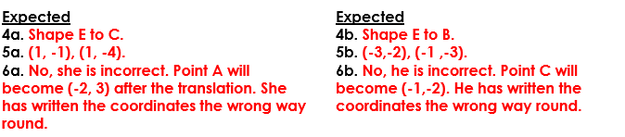

Reading - The Inept Magician

