Answers Thursday 14th May
Grammar – Recognising the passive verb
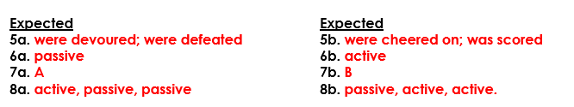
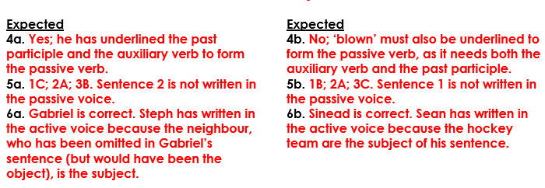
Year 5 Maths – Reflections with co-ordinates
