Answers Wednesday 13th May
Year 5 Maths – Reflection
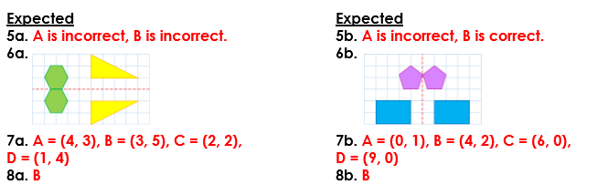
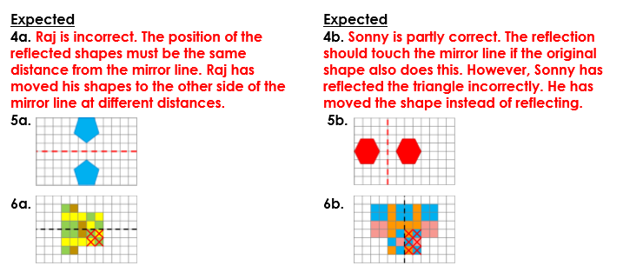
Year 6 Maths – Four Quadrants

