Answers Monday 11th May
Grammar – Identifying verbs in sentences
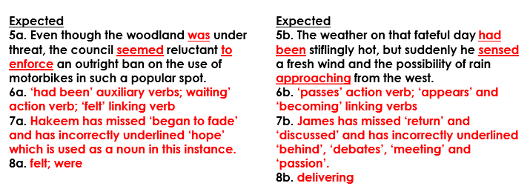
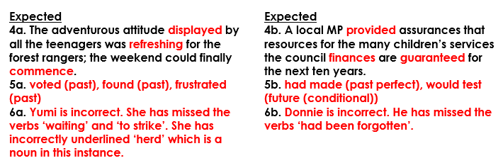

Year 5- Maths Position in the first quadrant
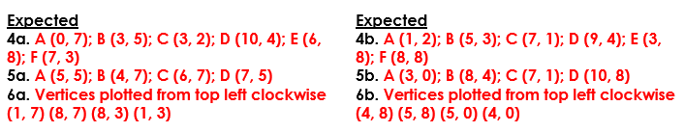
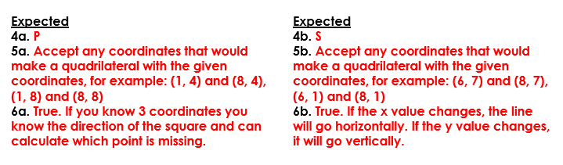

Year 6 Maths – The first quadrant
