Answer Tuesday 5th May
Year 5 Maths Converting Units of Time
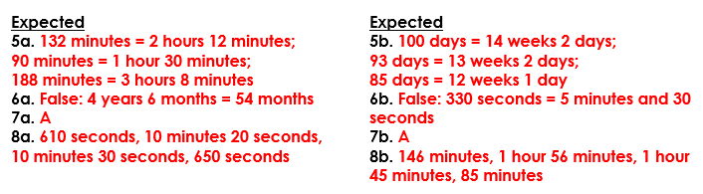
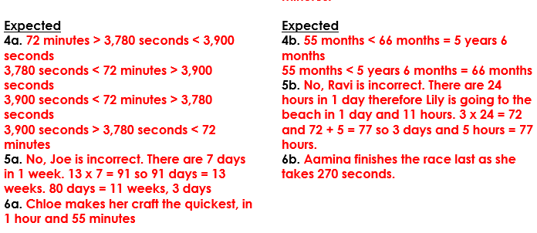
Year 6 Maths Convert Metric Measures
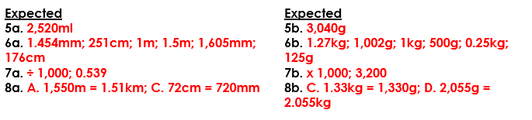
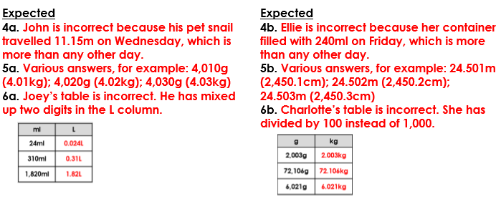

Grammar Concise Noun Phrases
