Answers Monday 4th May
Year 5 Maths Imperial Units
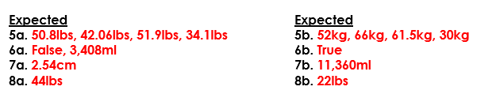
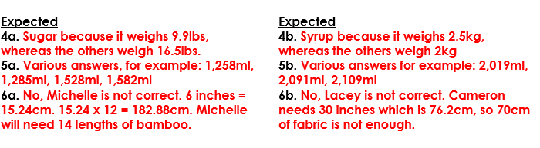
Year 6 Maths Metric Measures
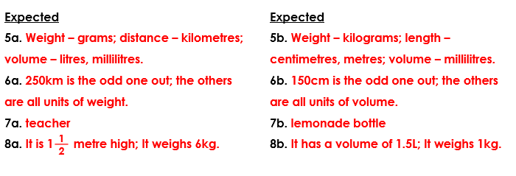
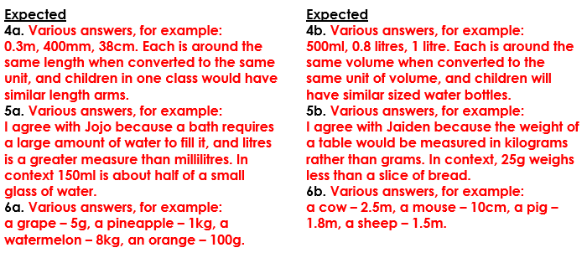
Reading A Soldiers Diary
