Answers Tuesday 28th April
Grammar – Adverbials
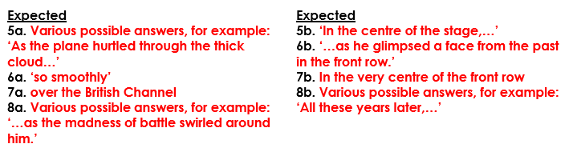
Year 5 Maths Kilograms and Kilometres

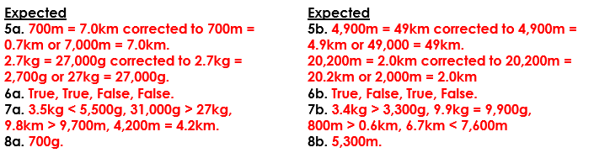
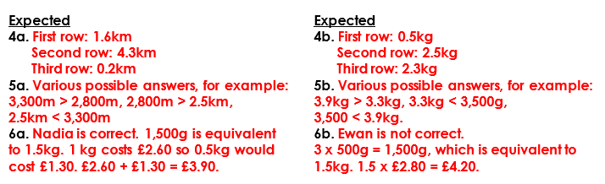

Year 6 Maths Area of a Parallelogram
