Hello Woodpeckers, I hope you’re all well and enjoying the Spring sunshine. I’m missing you very much and looking forward to seeing you again soon.
I hope you have fun with this little music quiz that I made for you.
Music Quiz:
As you know, the notes in the spaces on the music stave spell out the word FACE and the notes on the lines can be remembered by the phrase Every Good Boy Deserves Football. Using this information, can you work out the following words. Hints: Number 4 is a sentence and don’t forget Doris the Dog!
1)

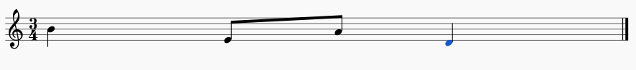
2)

3)

4)

Can you make up some of your own to share?

