Answers 21/4/20

Answers Pronouns to Avoid Repetition
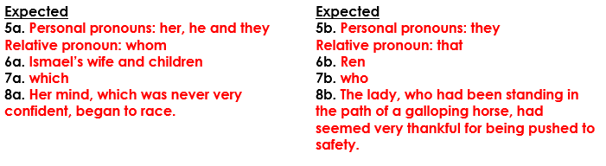

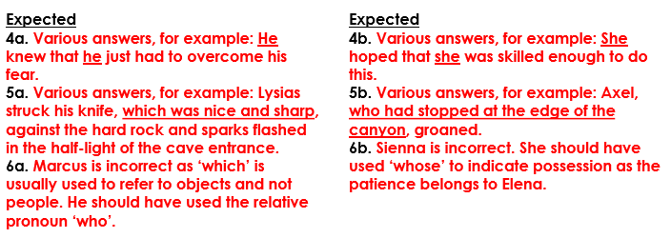

Maths Year 5- Calculate Perimeter
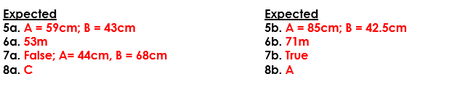
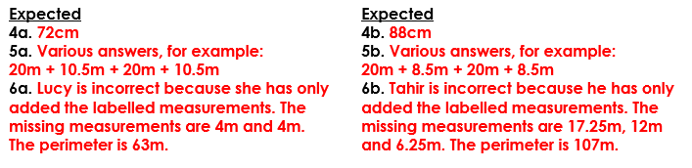

Year 6 Maths-Area and Perimeter
