Answers 20/4/20
Kindertransport Reading Comprehension Answers
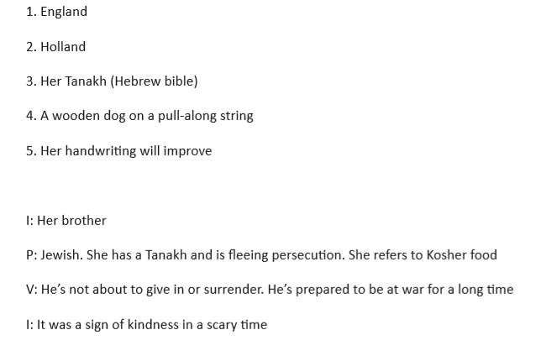

Maths Answers Year 5- Measure Perimeter
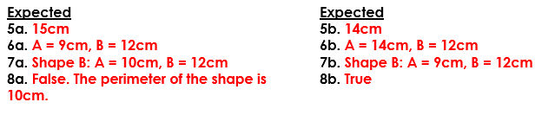
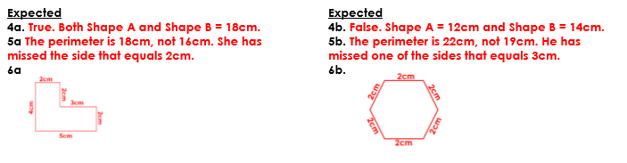

Maths Answers Year 6- Shapes Same Area
