compare | nd out who/what or something To look at similarities and differences
significant | Great or important
explain | To make an idea/situation clear by describing it in more detail
justify | To show or prove to be right or reasonable
region | An area of the country with characteristics | 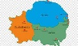
respond | To say or react in reply
interpret | Explain the meaning
evident | Clearly seen or understood
create | To make or cause something
settlement | A place where people establish a community | 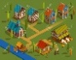
impact | To have an effect or influence
affect | To make a difference
topography | The surface features of land | 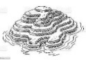
scale | The size of something | 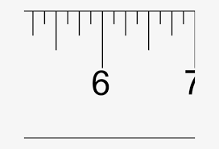
Extensive | Covering a large area
terrain | An area of land with its natural features | 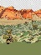
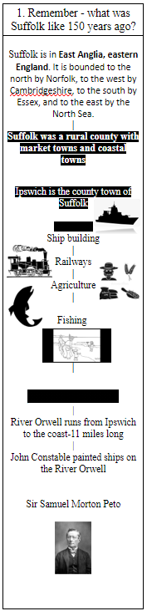
During this topic, we will be Historians and will investigate:
- What was happening globally 150 years ago?
- What was Suffolk like 150 years ago?
- What was significant about Lowestoft?
- What was significant about the River Orwell?
- Why did Suffolk become a holiday hotspot?
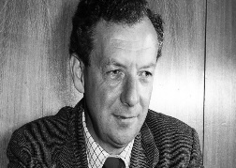
As musicians, we will be learning about a famous composer from Suffolk called Benjmain Britten.
Background -
The composer: Benjamin Britten (1913 - 1976)
• English composer
• Born in Lowestoft, studied at Royal College of Music and then made his home in the seaside town of Aldeburgh
• Was made a Baron – the highest honour a British composer has ever been given
The music: Storm Interlude
• Written in 1945 as part of an opera called Peter Grimes that tells the story of a lonely fisherman
• One of four interludes that were used between scenes in the opera to cover stage moves
• The interludes are now perhaps even more famous than the opera. This one describes a storm at sea

In PHSE, we will be learning about the differences between wants and needs. We will look at rights and why these are important and link this to the UN Convention of the rights of the child. We will learn how with rights come responsibilities and that these responsibilities affect our actions both at school and at home. We will also look at developing our understanding of democratic decisions and how these affect our lives and our ability to listen and give opinions.

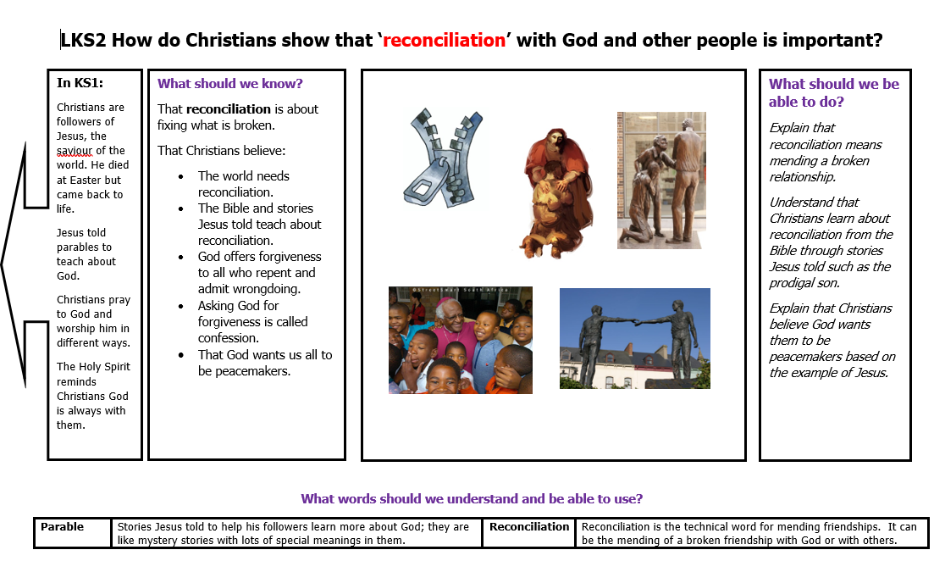
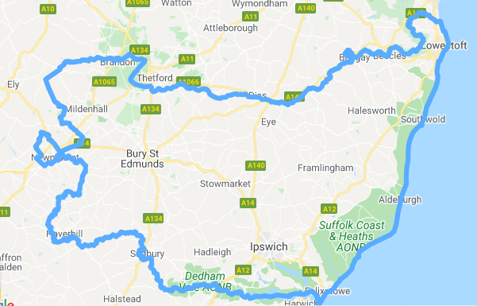
As Geographers, we will be comparing and labeling maps of Suffolk. We will also look at population data and discuss patterns. Suburbanisation was increasing and we’ll consider: decline in fishing, expanding holiday industry, agricultural depression, roads and car development as well as dock development.

We are going to learn greetings in French words and introduce ourselves:
Curriculum Enrichment –We will be learning about the Royal Navy’s connection to Suffolk from Joseph’s Dad.

Bonsoir! – Good evening!
Bonne nuit! – Good night!
Salut! – Hi! / Bye!
Comment ça va? – How are you?
Ça va bien, merci! – I’m well, thank you!
As artists, we will be learning about famous Suffolk artists John Constable, Thomas Gainsborough and Maggie Hambling. Can you name these pieces of art?
Comme-ci, comme ça! – So, so!
Ça va mal! – Not good!
In English we are going to be poets and learn how to structure a poem. Then we will write our own poems about autumn.
