Thank you for our equipment
From Wolves Class
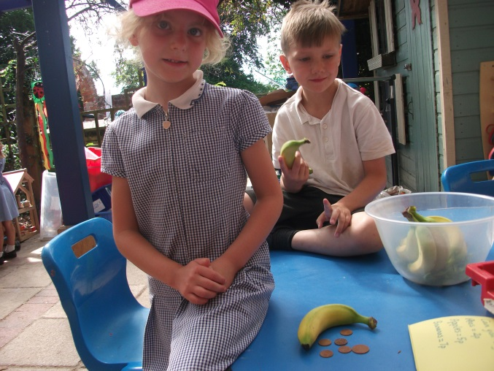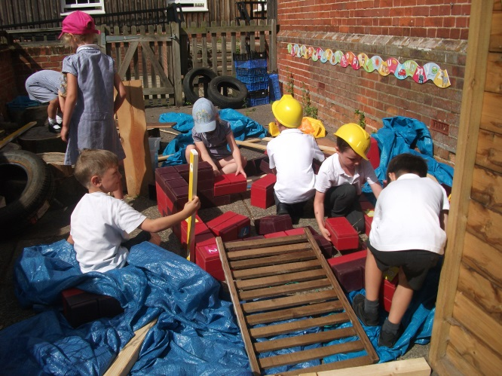
The snack shop with shopkeepers in action. The large construction area with children from all year groups working together to build a castle with drawbridge that went up and down.
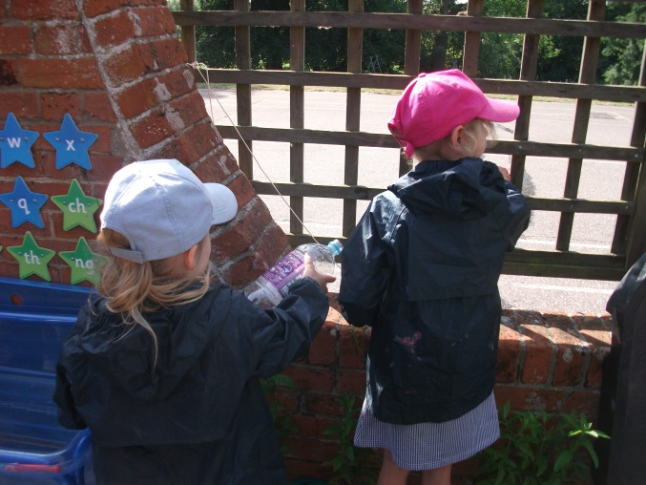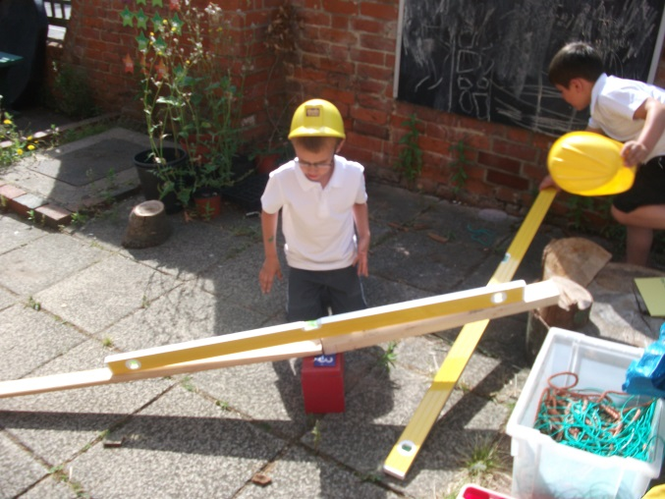
We love our new water tray with tubes, drain pipes and syringes and our spirit levels to help us build straight. We have also bought storage boxes, a new hose reel for topping up our donated water butts, a storage trolley and phonic resources with the £1000 you donated to improving our classroom areas. Thank you to parents who have donated items to our mud kitchen, large construction area and classroom and to Kelan’s Dad, Doug and Trinity’s Dad, Spike for their DIY skills.

